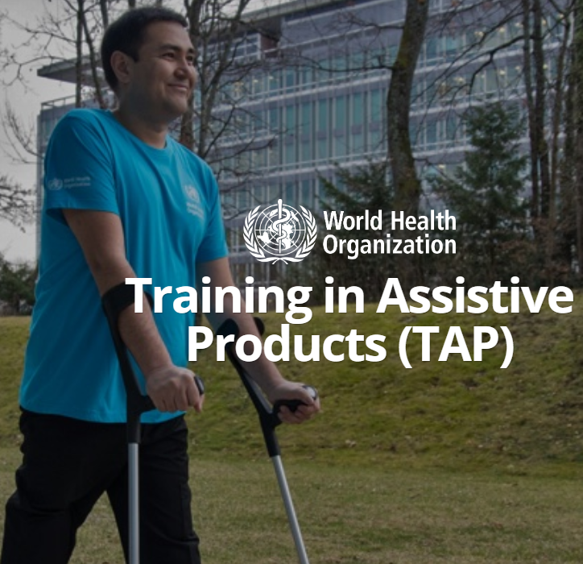**Overview:** Assistive products are used by children, adults and older persons to overcome a functional limitation which may be associated with having a disability, health condition or age-related decline [1-5]. The World Health Organization (WHO) has published a list of 50 ‘priority’ assistive products, which includes a wide range of products such as wheelchairs, continence products, hearing aids and glasses [6-9]. The people who use assistive products are as diverse as the product range; however, they are unified by the impact successful and sustained access to these devices can have on their lives. Global reports on disability, ageing, vision and hearing identify assistive products as enablers [10-12]. Literature highlights the impact of assistive products on enabling people’s full and inclusive participation in all areas of life including education, health and healthy ageing, employment, as well as social and political participation. Access to assistive products has been identified as a right for people with disabilities, “a mediator and a moderator” towards achieving the Sustainable Development Goals, and a component of universal health coverage [13-18]. The WHO uses the term assistive technology to describe the ecosystem needed for effective provision of assistive products including product supply, services, personnel, policies and financing mechanisms [19-20].

**Key facts:** **2.5** billion people today and **3.5** billion by **2050** need assistive products such as wheelchairs, glasses, hearing aids, white canes and more [1-3]. These are devices that may be used by children and adults with disabilities, people living with chronic health conditions including neglected tropical diseases and noncommunicable diseases, older people and people with mental health conditions [14-18]. For many, assistive products are essential for health, well-being, participation and inclusion, and yet access to assistive technology varies from **3%** in some low-income settings to **90%** in some high-income settings with lack of access to assistive products, particularly in low- and middle-income countries [21-22].

**Barriers to access are multi-dimensional and include** low awareness and limited demand for products and services; limitations in product innovation and supply chain challenges; and a chronic shortage of personnel equipped with knowledge, skills and resources to systematically provide assistive products. Countries with the highest prevalence of disability related health conditions tend to be those with the lowest supply of health workers skilled in this area [23-27].

**WHO mandate:** The World Health Assembly resolution 71.8 (WHA71.8) on improving access to assistive technology states “the inclusion of assistive technology, in line with countries’ national priority and context, into health systems is essential for realizing progress towards the targets in the Sustainable Development Goals relating to universal health coverage, inclusive and equitable quality education, inclusive and sustainable economic growth, full and productive employment and decent work for all” [24-28].

**The workforce challenge:** Due to an extreme shortage of health care workers trained to provide assistive products, realising the intent of WHA71.8 and the recommendations from the WHO and UNICEF Global Report on Assistive Technology, requires new approaches for workforce preparation and support. Traditionally, training in assistive technology is delivered face to face, and targets tertiary level personnel. There are, however, strong arguments to support the up-skilling of primary and other health care personnel to play a role in assistive technology. The 2018 Declaration of Astana identified Primary Health Care as the ‘cornerstone’ of a sustainable health system for universal health coverage. Worldwide, primary health care has been demonstrated to enable better access to health services, improved health outcomes and a reduced burden on secondary and/or tertiary level services [27-29].

**Introducing Training in Assistive Products (TAP):** To build the capacity of the primary health care workforce in particular, to play a role in assistive technology, WHO developed TAP, an open access online training resource, launched in November 2022 to help prepare primary health and other personnel to fulfil an assistive technology role and support countries on the road to universal health coverage. TAP targets community and primary level personnel and non-assistive technology specialist health care personnel who are expected to fulfil an assistive technology role; TAP is also relevant for rehabilitation, nursing and medical personnel who do not have formal training in assistive technology. The TAP online platform is designed for TAP learners, mentors and coordinators and offers 22 modules divided into 6 streams: Cognition, Communication, Vision, Hearing, Self-care, and Mobility. TAP uses a blended learning approach and is delivered with the assistance of mentors. These are usually personnel in the implementation country with the required knowledge and expertise. Mentors contextualise training content, provide learners with support during online training, and facilitate practical sessions. In-country implementation of TAP is almost always supported by a project coordinator [24-29]. The WHO recommends that TAP is implemented as one component of a comprehensive programme of support to strengthen assistive technology, rather than as an isolated training activity. Comprehensive support ideally includes addressing the policy, systems and resources needed for personnel to fulfil an assistive technology role after training. A coordinators’ web page on the TAP platform provides guidance to assist project coordinators in this comprehensive approach to programme planning, implementation, and evaluation [23-28].

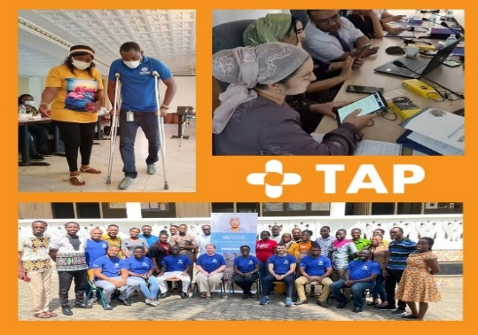**TAP Platform as a data collection tool:** The TAP online platform has inbuilt capacity to collect, with informed consent, descriptive information about TAP users and to host surveys. This function of the TAP platform offers a unique opportunity to build an understanding of the characteristics of the community and primary workforce and their mentors. It also enables the capture of TAP user perspectives across multiple countries and contexts regarding the relevance, impact and challenges of TAP training and practice. This data has the potential to inform future TAP development and other strategies intended to expand and support the assistive technology workforce, and ultimately to increase access to assistive technology [25-31].

**WHO TAP impact:** One TAP learner said: "This is an amazing platform to learn about assistive technology with very informative and interactive modules!”. TAP is a key component of comprehensive assistive technology services and training. To date, TAP is the only readily available comprehensive multi-language assistive technology educational online open access global resource that supports educators and learners and helps professionalize and develop assistive technology knowledge and hands-on skills. Integrating TAP into healthcare systems helps improve the quality of assistive technology service provision and increase access to affordable assistive technologies worldwide.

**Get involved! Join WHO TAP global community and enjoy learning:** Healthcare professionals worldwide are among the primary skilled personnel who play core role as leaders and change agents at the front line of assistive technology provision and advocacy efforts and can provide unique insight regarding assistive technology access and use across the world. To learn more about TAP, please visit TAP site and watch TAP introductory video: <https://www.gate-tap.org/>

**References:**

