
PMG Conference 2022
Monday 11 July – Wednesday 13 July
The International Centre, Telford
Exhibitor Electrical Requirements

Contact name: Samantha Heathcock
Company Name: Etac Ltd.
Address: Unit 60 Hartlebury Trading Estate, Hartlebury, Kidderminster,

Postcode: DY10 4JB STAND No. 13 & 14
Tel Nº: 07861 479141 Fax Nº: N/A
MARK THE POSITION OF YOUR SOCKETS BELOW
or use the form on the next page to confirm the position of sockets
Front Of Stand

PMG Conference 2022
Monday 11 July – Wednesday 13 July
The International Centre, Telford
Exhibitor Electrical Requirements

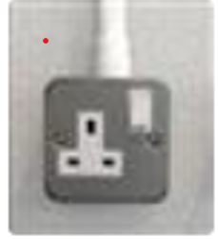
1 x 500w Socket is included with every 6sqm shell scheme.
Select and enter at least 1 and no more than 10 from below.

Total Number required 4

Socket position: Select minimum of 1 and up to a maximum of 6 from the positions below:

Stand Position | Number required
Back left corner (when looking into stand) | 2
Back middle of wall (when looking into stand) | 0
Back right corner (when looking into stand) | 2
Front left leg of stand (when looking into stand) | 0
Front middle leg of stand (when looking into stand) | 0
Front right left of stand (when looking into stand) | 0

