
PMG Conference 2022
Monday 11 July – Wednesday 13 July
The International Centre, Telford
Exhibitor Electrical Requirements

Contact name: Brent McIvor
Company Name: R Healthcare
Address: Unit 25 Whistleberry Park, Hamilton, ML3 0ED

Postcode: ML3 0ED STAND No.31
Tel Nº: 07825085813 Fax Nº:
MARK THE POSITION OF YOUR SOCKETS BELOW
or use the form on the next page to confirm the position of sockets
Front Of Stand

PMG Conference 2022
Monday 11 July – Wednesday 13 July
The International Centre, Telford
Exhibitor Electrical Requirements

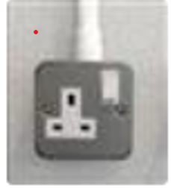
1 x 500w Socket is included with every 6sqm shell scheme.
Select and enter at least 1 and no more than 10 from below.

Total Number required 4

Socket position: Select minimum of 1 and up to a maximum of 6 from the positions below:

Stand Position | Number required
Back left corner (when looking into stand) | 2
Back middle of wall (when looking into stand) | 2
Back right corner (when looking into stand)
Front left leg of stand (when looking into stand)
Front middle leg of stand (when looking into stand)
Front right left of stand (when looking into stand)

