
PMG Conference 2022
Monday 11 July – Wednesday 13 July
The International Centre, Telford
Exhibitor Electrical Requirements

Contact name: DARREN LEGG
Company Name: DIETZ MOBILITY UK
Address: STAPLES CLOSE, REDHILL BUSINESS PARK, STAFFORD

Postcode: ST16 1WQ STAND No. 50
Tel Nº: 0333 011 5844 Fax Nº:
MARK THE POSITION OF YOUR SOCKETS BELOW
or use the form on the next page to confirm the position of sockets
Front Of Stand

PMG Conference 2022
Monday 11 July – Wednesday 13 July
The International Centre, Telford
Exhibitor Electrical Requirements

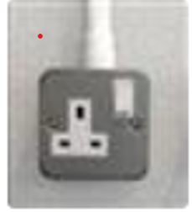
1 x 500w Socket is included with every 6sqm shell scheme.
Select and enter at least 1 and no more than 10 from below.

Total Number required 1

Socket position: Select minimum of 1 and up to a maximum of 6 from the positions below:

Stand Position | Number required
Back left corner (when looking into stand)
Back middle of wall (when looking into stand)
Back right corner (when looking into stand) | ONE
Front left leg of stand (when looking into stand)
Front middle leg of stand (when looking into stand)
Front right left of stand (when looking into stand)

