The Sacrum, The Pelvis and Obliquity

THE SACRUM

a discussion

Stephen Kebbell (MRCOT)

PREAMBLE:

At work, another senior therapist and I started talking about pelvic obliquity. Her opinion was that the orthodox approach to pelvic obliquity correction with IT build-ups was ineffective in practice and that she was unable to visualise how a flexible obliquity could be made level by placing it on an un-level surface.

In my experience in practice, I have had variable success with the orthodox approach to obliquity correction. This basically suggests we should apply an IT build-up under the lowest side of a correctable obliquity and to accommodate a fixed obliquity by applying the build-up under the higher IT. If a pelvis were flexible and ideally to be laterally level, how could this be achieved on an uneven surface?
Flexible Obliquity Pelvis levelled Pelvis unlevel in
IT Build-Up Cushion No support to right counter-obliquity
Similarly so, in the case of fixed pelvic obliquity building up the high side would seem to be effectively locking the centre of gravity in place; keeping it pushed away from balance. Weight bearing and pressure risk being kept to the lower side. In extreme cases seen in casting clinics, “de-rotating” is a term that is sometimes used, that is, changing the lateral orientation of the seating to gravity and ergo the pelvic angle; effectively raising the lower side of the fixed obliquity towards the horizontal. Of course, it all depends on the presentation of the patient and their unique seating needs.

I thus started reading around the subject of pelvic obliquity when I came across the 2015 PhD thesis “The Measurement and Correction of Sacral Obliquity”, by Dr John Dulhunty at Macquarie University in Australia. This thesis proved to be a rabbit-hole and as a Wheelchair Therapist, I couldn't help but to see the significance for our practice and understanding of the pelvis and spinal posture through sacral involvement. Although it answered some of my questions, it raised many, many more.

Dr Dulhunty's methodology and conclusions were concerned with the accurate measurement of the dihedral articulations of the sacrum from radiographic imaging. Delhunty also underlines that the study was not looking at prevalence or clinical utility but, it does give us rationale and insight into this and is worthy of discussion and consideration.

Dr Dulhunty included many x-rays and diagrams that have been used in this article as I would otherwise be unable to acquire or reproduce. He used many radiographic photos and techniques to demonstrate his points. I have been informed by Macquarie University that Dr Dulhunty has sadly passed away. The x-rays and images used in this article are reproduced from his thesis and the rights are thus owned by his estate. These images have been reproduced for non-commercial purposes of education and research.

The Sacrum (Os Sacrum. Latin: The Holy Bone)

The sacrum has a long and complex history and has apparently been the cause of much controversy and division in understanding of its function and evolution. Most investigations of the sacrum's shape and angulation as part of the pelvis has focused on anisomelia in otherwise walking patients rather than those in sitting. Some argue that as anisomelia is common (mostly rather small differences) the resultant formation of the sacrum as a reaction to this will inevitably align S1 to be horizontal to gravity in standing and walking and thus not clinically significant. Others argue that this can be the cause of acute back pain and uneven weight bearing. Sacral deformities seem to be less well studied in disability though some investigations have looked at Spina Bifida and the effects of meningioceles to sacral formation as well as Cerebral Palsy.

The pelvis, as we know, is made of the six inomminate bones (iliae , ischiae and pubii), five fused sacral bones and four fused coccyx bones. It has six articulations (seven if symphasis pubis is included) two acetabula, sacro-coccyx, lumbo-sacral and two sacro-iliac joints.

The sacral bones begin to fuse between ages 16 and 18 with becomes a single bone around the age of 26. The sacrum distributes bodyweight through the sacroiliac joints to our legs in standing and ischial tuberosities in sitting. Without leg-length discrepancy or exacerbating factors, the lumbo-sacral joint is horizontal to gravity in sitting and sanding and connects the sacrum to the L5 vertebrae

The sacrum does not have independent active movement but moves passively in reaction to movements of the inomminate bones during walking and sitting to produce the movement of nutation from the traction of pelvic ligaments and tendons . The effect of nutation upon the sacro-spinal ligaments is important in supporting the natural relaxed lumbar lordosis in sitting and standing with less energy expenditure and muscle involvement. Upon eliciting full nutation the suerior and inferior articulating surfaces of the lumbar vertebrae wedge together limiting lateral flexion. Counter-nutation has the opposite effect and prevents this alignment against gravity in both the saggital and coronal planes. The reader may wish to try sitting erect and kyphotically and note the difference in lateral flexion available to them. The reader may notice that if sat in good erect posture on a neutral to anteriorly rotated pelvis and leaning to one side, that upon maintaining this lean and transitioning to a posteriorly rotated pelvis that they would notice an increasing range of lateral flexion. Nutation at the sacroiliac joint is an important factor in maintaining spinal alignment by changing the sagittal angle of the S1 Lumbo Sacral joint. Nutation also assists us in walking and standing. The range of movement in the SI joint during nutation may be small but has a significant effect on our posture and thus function. The coccyx and sacro-coccyx joint also have an important function in maintaining good sitting posture due to it's movement and as an insertion point for tendons. The sacrum also allows for the iliac crests to 'flare' and is also an important movement during partum.

The SI joint also acts a shock absorber during walking and has a very small degree of elevation/depression in normal presentation and is held together with the stongest ligaments of the body. SI joint dysfunction can be the cause of considerable pain and will often present itself as lower-back pain centred medially to PSIS.

The sacrum is also liable to a variety of deformities through normal skeletal development, injury, or degenerative pathologies affecting its shape and articulating surfaces. The SI ligaments and tendons can become ruptured or slackened resulting in instability and the migration of the whole joint upward or downwards referred to as up-slip or down slip also by Dr Dulhunty. Up-slip may happen as a result injury, e.g. by landing on one leg from a height or Down-slip when a rider falls off a horse and dragged by one stirrup.

During bone development, the final fused shape of the sacrum and thus angle at the sacral base can be affected. This can be seen in certain cases of spina bifida for example. Sacral base integrity and formation is also an important factor in surgical spinal correction in Cerebral Palsy

Thus, it would not be unexpected to find in clinic a person who has one sacroiliac joint fused and the other unstable and elevated in up-slip. One may find someone who's SI joints are fixed in counter-nutation resulting in corrected seating being a physical effort to maintain, the ligament support to the lumbar spine being denied (rather like standing on slightly bent knees without the locking action of the cruciate ligament). The variation of deformity, fixation, laxity in the SI joints are wide.

OBLIQUITY

Oblique [/əˈbliːk/] :adjective: neither parallel nor at right angles to a specified or implied line; slanting

Pelvic obliquity could be defined as any deviation of the horizontal plane of the pelvis from level and is usually measured in an upright posture by comparing the relative height of the iliac crests to see if one side of the pelvis is higher than the other. We assess this in clinic by palpating ASIS and PSIS as we have all been taught, though Delahunty argues that this may often be less reliable than we may assume due to the independent movement of the sacrum within the structure of the pelvis.

Delahunty, using radiographic evidence, looked at the relationship between the angle of the S1 lumbosacral joint against the force of gravity and offers us two definitions. Absolute Sacral Obliquity and Relative Sacral Obliquity.

Relative Sacral Obliquity Dulhunty defines as the “ ...angulation of the sacral base in the frontal
plane in relation to other structures, primarily the ilia, femur heads or lumbar spine and
generally represents internal pelvic or sacral asymmetry. This relationship would remain
unchanged with various orientations of the structures to gravity e.g. standing, sitting or lying
down.”

Absolute Sacral Obliquity “refers to the angulation of the sacral base in the frontal plane for a
specified orientation of the body in a global reference frame or in relation to gravity for a
specific posture such as standing or sitting.”

Therefore, not only is the angle of the pelvis or I.T.s to be considered but also the status of the sacrum within it to understand the spinal alignment and postural support required by a wheelchair user.

Drawing reference upon work conducted by Juhl et al (2004) the focus upon which was pelvic deformities in patients with anisomelia, Delahunty also considered the effects of such deformities upon sitting as well as standing and offers us 6 patterns of obliquity with a seventh orthogonal or 'normal' pattern. 13 different pelvic positions in all, six to the left and six to the right plus 'neutral'. Juhl et al identified the same patterns though their sequence of numbering had little meaning or relationship to each other.

These six patterns of deformity describe the relationship between the pelvic angle as a whole and the angle of the sacral plateau at the S1 joint within the pelvis. As will be seen, in sitting, just because the pelvis is oblique does not mean that the sacrum or the S1 joint follows this obliquity. The sacrum may be level when the pelvis isn't, may follow the pelvis but may not be parallel to it or may be rotated in the opposite direction to the pelvis.

In Delahunty's work, these were issues seen generally in light of anisomelia. He considered the effects of the six deformities in both standing and sitting and the transition between the two. He shows how these deformities compensated for anisomelia in standing by levelling the sacrum against gravity.

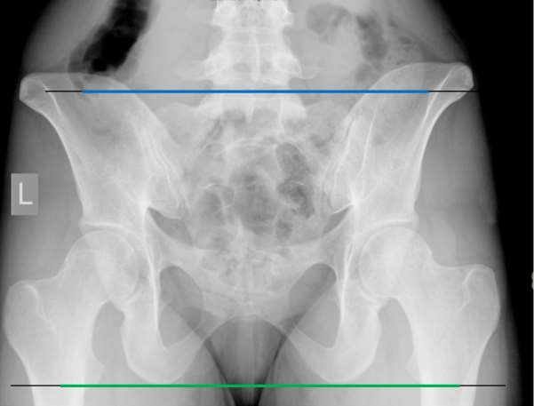
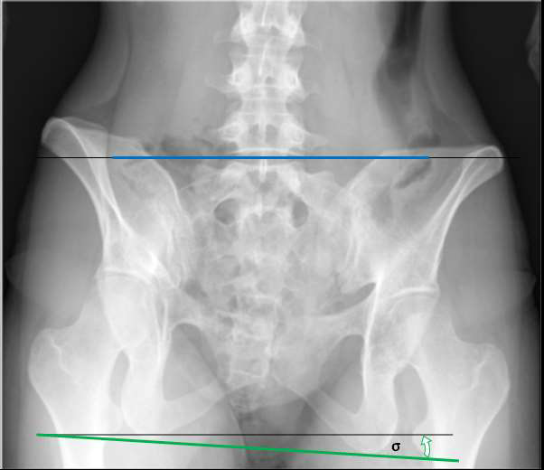
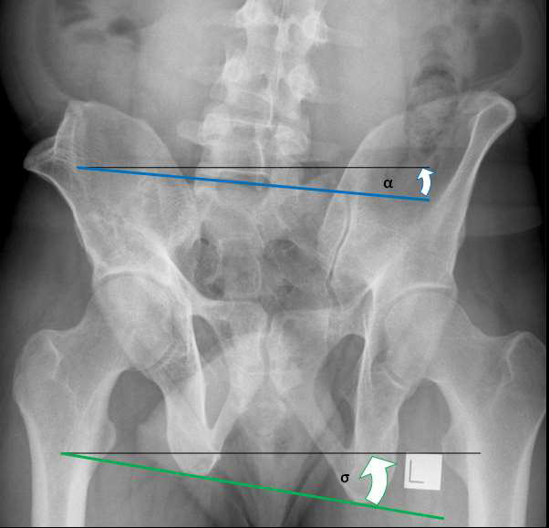
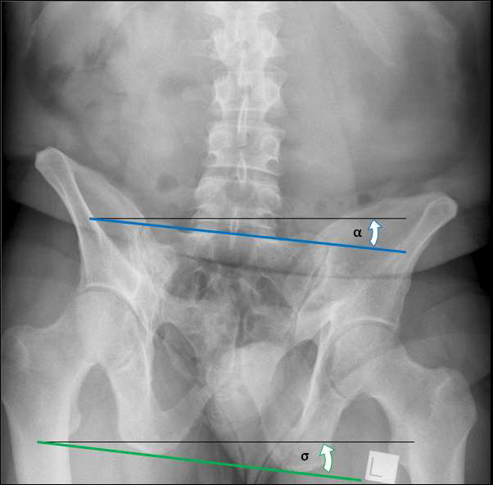
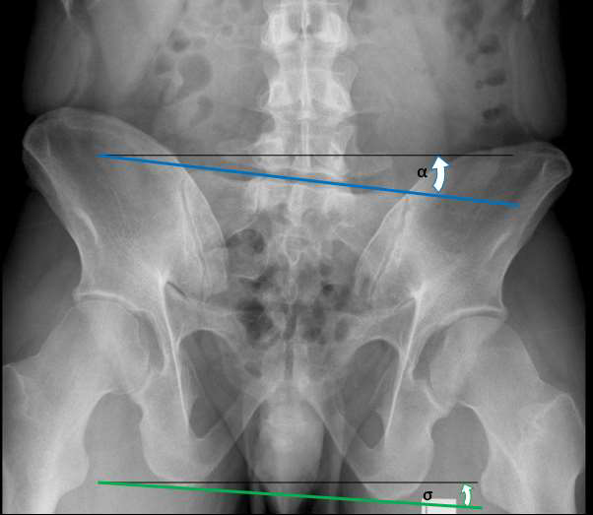
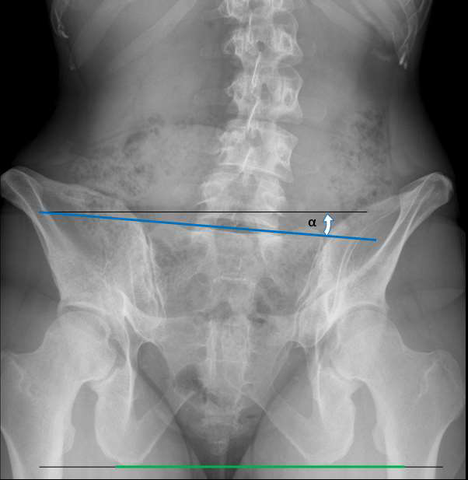
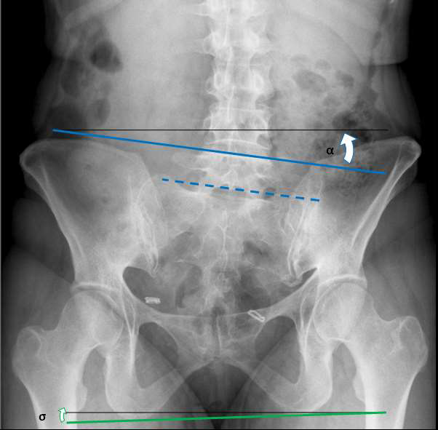
SOA – Sacral Obliquity Angle : ITA – Ischial Tuberosity Angle : Horizontal in magenta
CORRECTION OF ABSOLUTE SACRAL OBLIQUITY ANGLE IN SITTING

Dulunty also considered the amount of correction required by applying an IT lift in sitting (and leg length correction in anisomelia) and provides a mathematical model in order to achieve this. This does not necessarily mean, however, that these represent a clinically suitable or useable model and certainly did not consider wheelchair cushions .

He presents us in his findings a formulae for changing the vertical height of the ischial tuberosity in order to level the S1 joint using dimensions from a graphical model. This formulae being:

sin(σ - α ) * ITW for patterns 2 and 3
0 for pattern 4
sin(α - σ ) * ITW for pattern 5 and 6
sin(σ + α ) * ITW for pattern 7

where: α = angle of the S1 joint to horizontal ; σ = Angle of IT to Horizontal
ITW = Ischial Tuberosity Width

ITW was measured on radiographs as the points perpendicular to a tangential line drawn across the lowest points of the IT curve.

PELVIC DEFORMITY PATTERNS IN SITTING AND STANDING

PATTERN 2

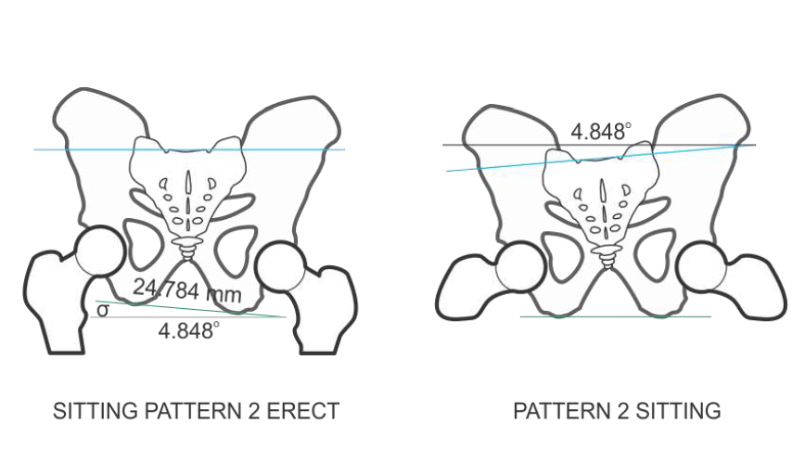
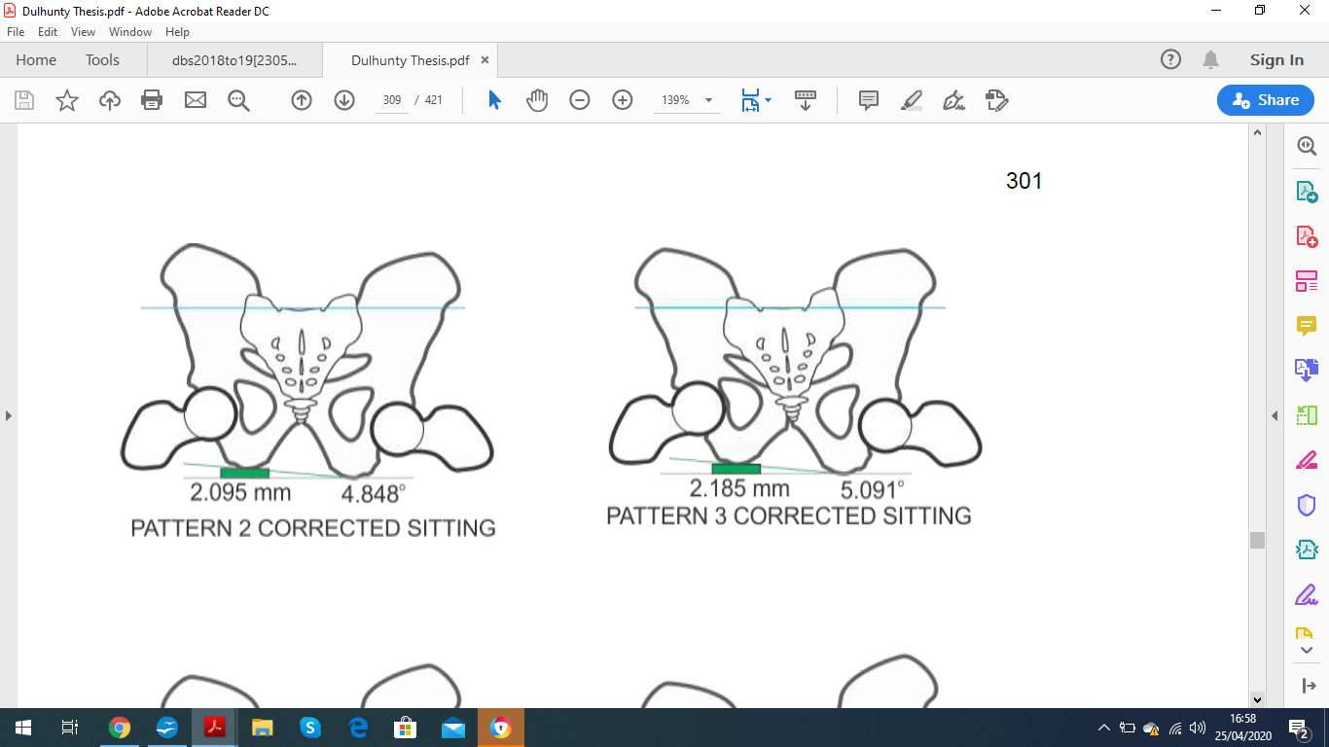
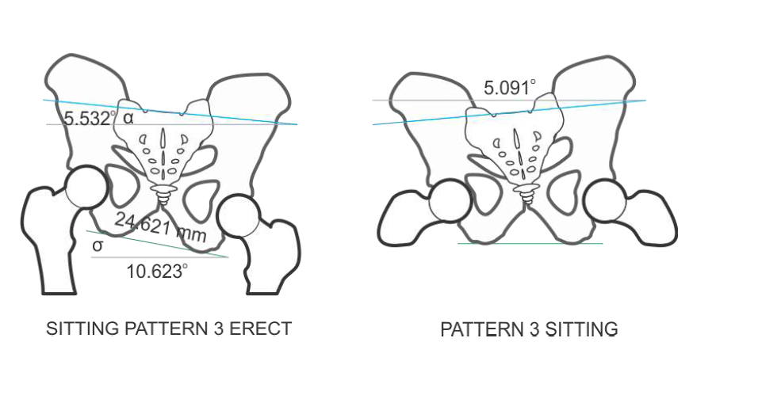
PATTERN 3

PATTERN 4
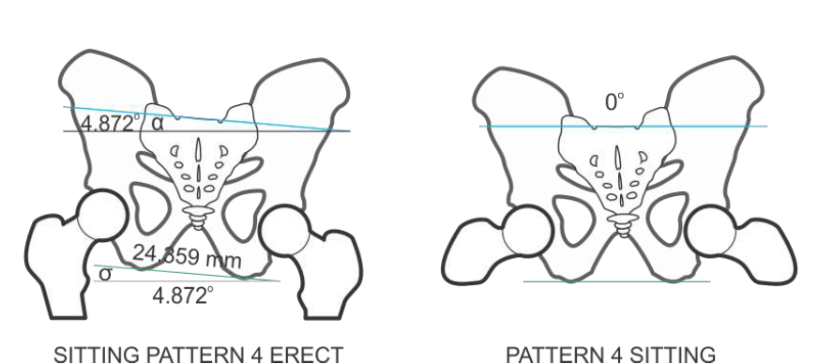
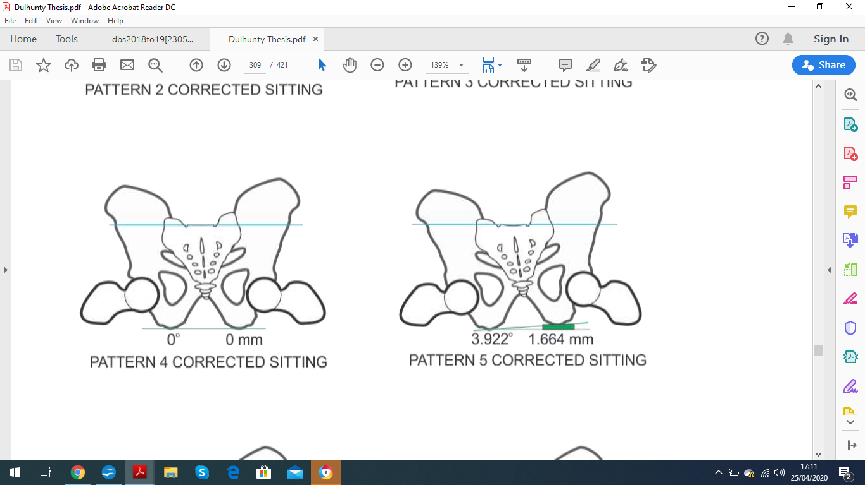

PATTERN 5

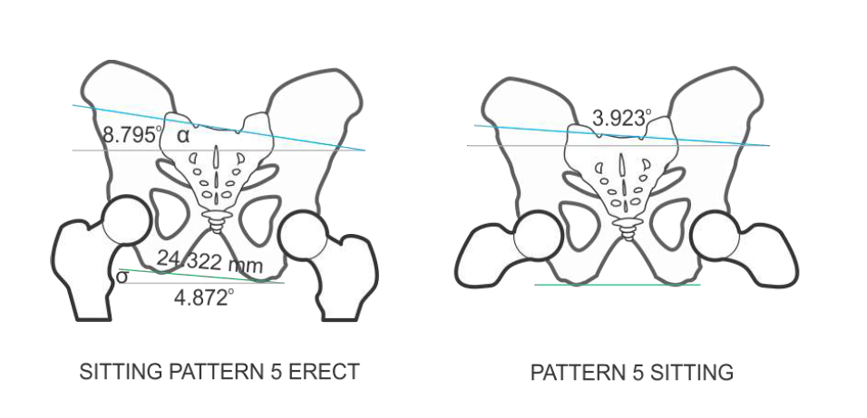
PATTERN 6
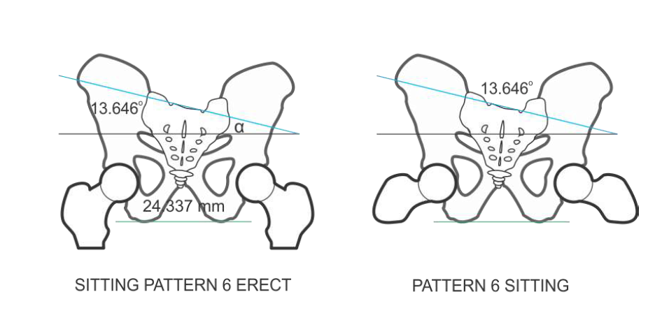
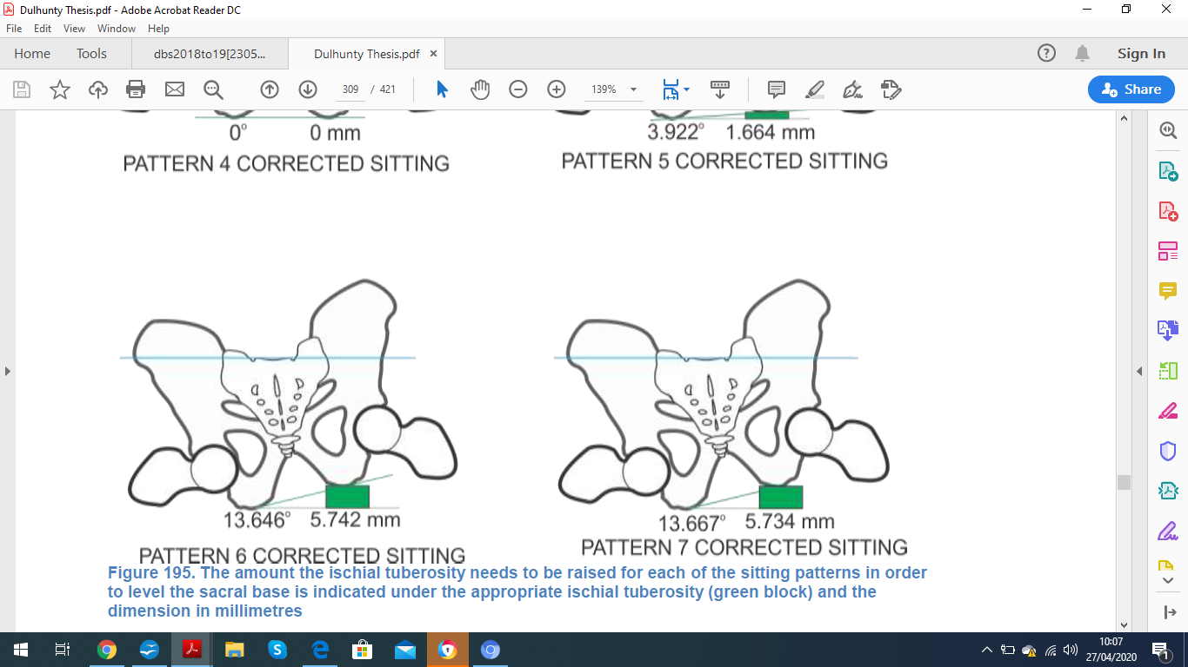

PATTERN 7

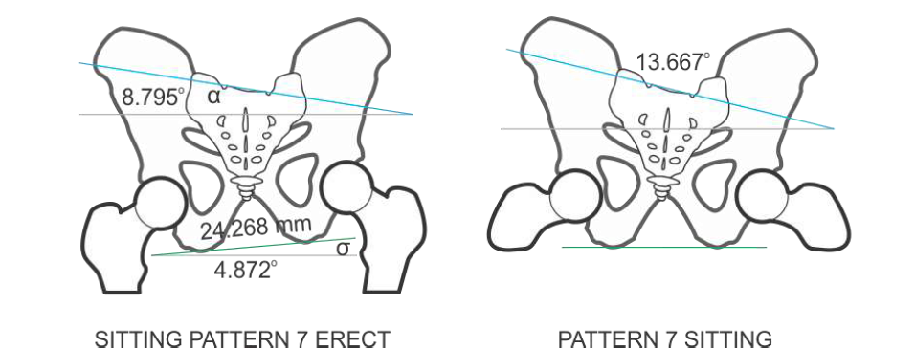
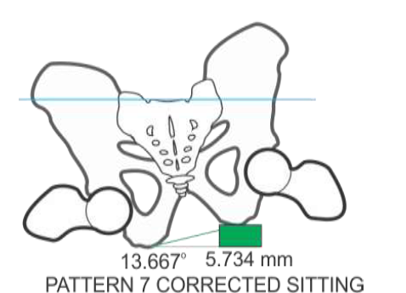

DISCUSSION

The movement within the sacrum is an important factor that seems to have been generally overlooked by many in wheelchair and postural seating provision and assessments. It is recognised that there are a multitude of considerations to be made in regards to successful seating. The sacrum can only be considered as an element of someone's postural patterns and requirements for good seating; spinal deformities, contractures, ligaments, pressure care, life-style, disability, prognosis, diagnosis etc.

It has also been interesting to look at the images of pelvic obliquity and correction being presented by some companies, texts, articles etc. Drawing lines on these images, across I.T.s and sacral plateau, can show an angular differences between the 'before' and 'after'; almost as if the graphic artists were unable to make the images fit otherwise. Some images seem to show a grossly deformed sacrum and ilium structures and again seemingly to get the images to fit. The reader may like to look again at these images again with a ruler and pencil to hand.

The image that is oft presented to demonstrate pelvic obliquity is that of Dulhunty's Pattern-4 sitting; the pelvis and sacrum perfectly formed and without any relative sacral obliquity. We often use the term “fixed” or “flexible” pelvic obliquity yet the picture seems to become rather more fractured in light of sacral involvement.

Good clinic and plinth assessments will reveal what works and is balancing for the patient in their seating and is a good practical approach to treatment, however, the awareness of the status of a patient's sacrum may guide better decision making when added to the complexity of variables that affect posture over time, e.g. muscle tone, fixed deformities, contractures, centres of gravity etc.

Firstly, the technique of palpating ASIS and PSIS would seem to only give part of the picture as to what the real situation is. This is also supported by Dulhunty. We are unable to rely on pelvic palpation alone to understand what is happening to the lumbar spine and the reaction to kyphosis. We are unable to accurately ascertain when the sacral plateau is indeed level. For example, the pelvis may palpate as oblique but the S1 joint is level due to up-slip at the SI joint.

It also needs to be considered that Dulhunty did not consider the orthopaedic complexity of people with disabilities. However, Jae Hwan et al note that sacral obliquity is “...frequent finding in patients with adolescent idiopathic scoliosis”. Jae Hwan et al also concur that up to 15% of the general population has anisomelia as found in previous studies. Vleeming et al also note that “Narrowing or obliteration of SIJs has been commonly reported in paraplegics”.

It is often taught that in the case of Pattern-4, if the pelvis is correctable then a raise should be placed under the lower side to correct it, bring it back to a vertical midline and redistribute weight loading through the ITs. Dulhunty's work suggests that this may not be the case. What seems to be evident an indication that cushions with IT build-ups should only be used where an absolute sacral obliquity is present in sitting (other factors excluded).

Perhaps we need to consider what is meant as fixed or correctable pelvic obliquity. The pelvis/spine as a whole can move only a few degrees at the S1 joint but a succession of lateral flexion of subsequent vertebrae as a movement of the lumbar spine will increase the apparent angle of pelvis to the horizontal plane and certainly affect the Absolute Sacral Obliquity of the S1 joint.

Maybe the terms of “fixed” and “correctable” pelvic obliquity should be considered more as a function of spinal scoliosis presentation rather than as a property of the pelvis itself. It may be better to describe an oblique pelvis not as “rotating up” or “raised” but rather “being rotated by hypertonic lateral flexion” for example. It may perhaps thus be argued that a true pelvic obliquity should only be regarded as fixed or correctable movement between L5-S1 at the lumbosacral joint; being a single axis of articulation. The rest of the angulation being the compound effect of the movements of other joints.

There are other considerations that need to be taken into account with complex disabilities and seating prescription and it is recognised that the effects on fixed scoliosis or kyphosis is not addressed, for example when taking into account pelvic angles in Dulhunty's thesis nor does he take into account pressure relief needs.

I have, however, seen patients complaining of lower-back pain in seating and on gentle palpation around the sacral fossa they would identify this as the location of pain and recognised the term “sacroiliac disfunction” as having been mentioned in external clinics.

Some sacral assessments exist but it is only really with radiography that the sitting patterns described by Dulhunty or Juhl et al could be confirmed. These look at the effects of the sacrum in movement, for example:

With the patient sitting facing away from you, palpate PSIS with thumb and ASIS with index finger. Ask the patient to lean forwards towards their knees. Both sides of the iliac crest should move equally. If one moves more than the other, a disfunction in the sacroiliac joint may be determined. Also, on plinth lying, cross one ankle across the opposite thigh and depress gently. If this results in sacral pain, an issue with the sacrum can be surmised.

Those seen in complex clinics are often at the extreme of human postural deformities. Though not regarded in studies, it would be reasonable to expect sacral deformities are highly likely to be present in a significant number of cases seen in clinic. With such complexities, an entire thesis could be written on just one person's pelvic presentation and evolution and it is reasonable to expect that meaningful outcomes measuring such extremes of variation across a client broad and complex client group would be very challenging.

Questions worthy of further investigation:

- How can we reliably assess, deduce or estimate the Absolute Sacral Obliquity angle or direction of sacral rotation in clinic? Can pressure mapping assist?
- How to assess movements of nutation and counter-nutation.
- How to deduce up-slip or down-slip
- What effect does a single fixed or lax SIJ have on sitting.
- The prevalence of sacral malformation in children with disabilities.
- The relationship between sacral deformity and malformation of acetabulae during childood.
- The coccyx – disability and seating.
- The effects of contractures upon sacrum, to include the minor muscles such as piriformis
- Pelvic ligaments and seatimg.
- How to treat sacral/pelvic obliquities more effectively in practice

etc. I am certain that the reader would understandably have many more.

The sacrum is an elegant and important structure. Its intrinsic movements may be small and nuanced but the effects would seem to be profound, also to our understanding of pelvic obliquity. It is recognised that the sacrum has a lot more to teach us about posture and seating and that this article has only touched on one or two aspects and in isolation of many multipliers such as different patterns of scoliosis and different diagnoses etc.

Further research and discussion certainly seems warranted

STEPHEN KEBBELL, MRCOT

References and Reading

John Dulhunty D.C., MACC, (2015) “The Measurement and Correction of Sacral Obliquity” (PhD Thesis) Macquarie University.

Vleeming et al: “The sacroiliac joint: an overview of its anatomy, function and potential clinical implications”: Journal of Anatomy . 2012 Dec; 221(6): 537–567.

Jae Hwan Cho, MD et al, “Association between Sacral Slanting and Adjacent Structures in Patients with Adolescent Idiopathic Scoliosis” , Clinics in Orthopedic Surgery 2017;9:57-62

Juhl JH, Ippolito Cremin TM, Russell G. Prevalence of frontal plane pelvic postural
asymmetry--part 1. J Am Osteopath Assoc. 2004 Oct;104(10):411-21.

Hasler, et al (2020) “Spine deformities in patients with cerebral palsy; the role of the pelvis”: Journal of Children's Orthopaedics Vol.14, No 1

All X-Ray and graphical image rights owned by the estate of Dr John Dulhunty DCMCC, and reproduced in accurate context for educational and research purposes and not for profit or commercial gain.

