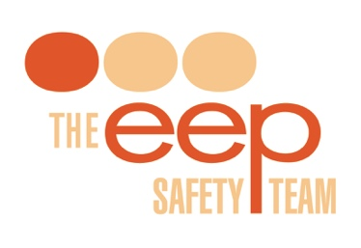

Risk Assessment **Questionnaire**

1. Full name of your Event: PMG Conference 2017
2. Venue: Motorpoint Arena, Cardiff
3. Who is your Venue Event Manager: Matthew Blackhouse
4. Event Dates and Times: 06:00 17/07/19 - 19/07/17 21:00 (including set-up/breakdown)
5. Anticipated visitor numbers: 580
6. Public or Trade event? Trade (educational conference with exhibition)
7. Do you have Shell Scheme and/or Space only stands? Both
8. Do you have any complex (over 4m) stands: Yes, one
9. Do any stands have vehicles on them: No
10. Do any stands have demonstrations on them: Yes
    1. If so what? Most will be demonstrating wheelchair and special seating equipment to other professionals (who work with wheelchairs and seating)
11. Do any stands have items of special risk? One has a fridge and soft drinks
12. Do any stands have gas bottles on them? No
13. Do any stands have helium balloons on them? No
14. Do you know of any Disabled visitors or staff? Yes: 7 wheelchair users (2 exhibitors, 5 delegates), 1 person who using a walking stick and 1 person who uses a hearing aid
15. Do you know of any expectant mothers visitors/staff? Yes, 1 delegate
16. What is the age range of visitors? 18 - 70 (predominantly professional working age: 25-60)
17. Do you have any after show parties? Yes, Welcome Event at Smoke Haus restaurant on 17/07/17, Drink Reception in exhibition on 18/07/17 following by Gala Dinner in space next to exhibition 18/07/17
18. Who is your appointed First Aid? Not sure, venue are providing, will ask
19. Do you require to order Fire Extinguishers for your event: No
20. Do you have a Safety Officer and/or Floor Manager? Yes, Steve from EEP Safety during set-up, first morning and breakdown only. Rest of time will be Venue Manager floor managing
21. Any other information you feel we need to know?  
    The venue will be cordoning off a section of the hall to use as a test area, if people want to try out wheelchairs. It will be 15m x 2m, on the north side of the halls between the male and female toilets.