**PMG 2016: A SPECIAL JOURNEY**

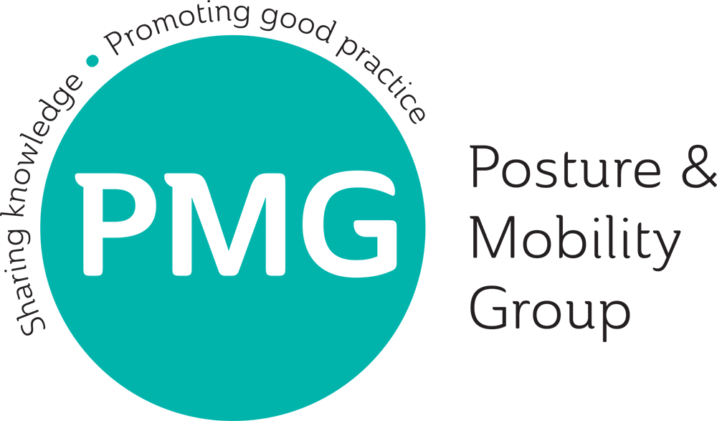

The PMG conference was my first and I have to say I was not disappointed. It has been the highlight of my placement if not my whole training so far. I had missed out last year but I was very fortunate and extremely grateful to be able to attend this year, so I was determined to make the most of it. As a student, I didn't expect to have much to say, so the plan was to "observe" proceedings and make important contacts where possible. The plan was executed, but there was more. I was wrong about my expectations, from the exhibitors to fellow delegates to the lovely PMG staff and executives - everyone was interested in knowing my interests as well as sharing their own involvement in posture and mobility. This was refreshing and reassuring; it made my experience even more enjoyable.

Ever since I started my training, I have always been proactive and utilised every opportunity to establish contacts with various organisations and professional bodies that deal with anything related to my speciality. This was partly because of the fact that I was not very sure of what I was getting into when I enrolled into my course, so I wanted as much information as possible. Today I have no regrets as I continue to develop professionally and individually, the PMG conference experience also played a big part in this journey. I am just coming to the end of my second year studying Clinical Engineering, specialising in Rehabilitation. I am currently on placement in South Wales and located at the Posture Mobility Centre with the Rehabilitation Engineering Unit. When I was introduced to PMG by my supervisor, I didn't hesitate to join and I quickly realised that they deal with issues that are at the core of the special seating services that we also provide. As a Trainee Rehabilitation Engineer, I have come to realise that services may differ in the way they work but the definitive goal of meeting service users’ needs is at the centre of it all.

Overall the conference, taking place at the iconic International Convention Centre (ICC) in Birmingham, was the ultimate melting pot of the brains and muscles actively pioneering research, education and service provision to the millions worldwide that require posture and mobility aids. Having access to the right information and equipment plays a big part in the care of patients. The PMG gave an insight into the services available around the country which I will happily utilise as I develop. I have already made the most of the handy list of delegates and exhibitors’ contacts as I have been invited to attend the Specialised Ability Centre in Manchester where I live. I wouldn’t have got this opportunity without the networking through PMG.

The remarkable exhibitions were also not to be missed; the staff were very enthusiastic in demonstrating their impressive products and answer countless questions from the delegates. It was here I didn’t feel like a student among professionals anymore, I found myself fully engaged and enjoying every minute of it. The diversity of the wheelchairs and accessories on show was just mind blowing; you could find everything for everyone to suit their personal needs; whether high-tech, low-tech or even no-tech! To me, the PMG conference served its purpose of bringing people together to network and share information on how and where to find the right solutions for the very complex postural or mobility needs of their clients.

I was genuinely impressed by the quality and content of the presentations at the conference. I was also challenged and motivated as I continue studying after I witnessed the wonderful work done by the various professionals up and down the country. Their enthusiasm and dedication was evident and there was also a noticeable benefit from collaborative working. A great example was the joint venture between the Tower Hamlets Wheelchair Service and the Barts Health NHS Trust in the provision of combined seating solutions. I believe clients having more than one seating and/or mobility system would benefit from such arrangements, with service providers saving significant amounts of time and the much needed financial resources. Other visibly important benefits included improved care through knowledge and resource-sharing as well as independence for patients. Ade Adepitan’s opening and Martin Gough’s plenary session presentations were among those that stood out for me. Mr Gough highlighted the importance of critically reviewing any intervention to ensure it significantly improves the lives of people with complex disabilities, considering their future comfort, function and not just their body structure.

Finally, the Aldersea Lecture was an excellent presentation by the Director of Public Affairs at the British Healthcare Trades Association (BHTA), Ray Hodgkinson MBE. It was a timely reminder of the positive influence of assistive technology in today’s society, also taking into account the cost effectiveness of harnessing technological advances in the delivery of healthcare. From the exhibition, it was apparent that posture and wheeled mobility expertise also relies heavily on these advances. It was therefore encouraging to know that the BHTA was committed to work with the PMG in mapping out the future through involving those new to the field like myself as well as addressing the need for the broad range of the necessary skills required and collective impact of the technological advances.

I cannot imagine what I missed in the previous events and I am already looking forward to the PMG 2017 Conference, which will be most-convenient as I will be in Cardiff for my final year placement at that time - the organizers have given me no chance to justify missing it!