RISK ASSESSMENT
Exhibition/Event: PMG conference Venue: Cardiff Motorpoint arena
Date of Exhibition/Event: 17-19th July 2017
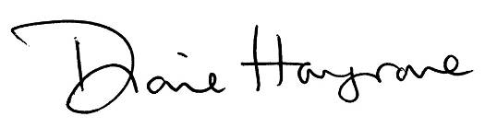
Date assessed: 22nd June 2017 Assessed By: Diane Hargrove
Signature:

Potential Hazard Identified | Consequences | Persons at  Risk | Worst  case  Outcome |  | Probability  Rating |  | Control Measures
Lifting and moving stock | Heavy items requiring movement to prepare stand and dismantle | Martin Walker, Manuel Haack, Graham Collyer | injury |  | Very low |  | All personnel fully briefed regarding safe moving and handling techniques and appropriate lifting with 2 personnel where appropriate
Lifting and moving literature boxes | As above | As above | As above |  | Very low |  | As above and removing empty cartons and keeping stand tidy at all times even during build and dismantle phase
Lifting and moving stand furniture | As above | As above | As above |  | Very low |  | As above
Demonstration of wheelchairs operation to show configuration | Potential for trapping hands in movable parts and running over feet | As above plus Diane Hargrove,Tess Cooper, stand attendees | injury |  | Very low |  | All personnel fully briefed, wheelchair brakes applied when not in use, area cordoned off where dynamic chair in use

