PMG Newbie!

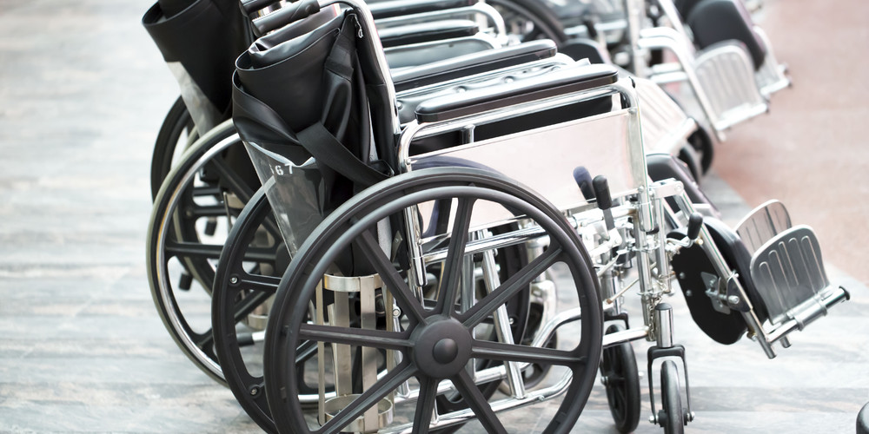

It was a welcome surprise in May 2016 to receive an email to say I had been awarded a bursary place for PMG. Mid July, only two weeks into my new job working as a Wheelchair Therapist in Swindon Wheelchair Service, I was off to PMG. As a newbie to the area and conference, I was excited to attend but did not know what to expect, having received all the emails and information on the conference programme beforehand, I knew it was going to jam packed!
My first challenge was finding the venue from the train station, on arrival I was welcomed by the friendly, helpful conference staff and pointed in the right direction for registration, where I joined the networking sessions on various discussion topics. As I was travelling on my own I found this invaluable to network and meet others prior to the conference and social event at marmalade that evening.
The next day the opening address from the chair of the conference was very informative and set the scene for what to expect over the next few days. I was impressed by the opening plenary session from Ade Adepitan MBE. To hear his story first-hand of the trials he has experienced as a wheelchair user growing up was both humbling and inspiring to listen to. However by channelling his energy and determination in a positive way, he has gone on to achieve so much including; competing as a wheelchair basketball player on an international level, TV presenting, and Whizz Kids Ambassador, he is such a great role model for young wheelchair users.
I attended the seminar on collaborative working joint funded seating, which I found to be very informative and relevant to my practice. Working in the past with individuals with neurological conditions for many years as a physiotherapist, specialist seating and support was always a massive dark hole for clients and a big bugbear of mine. Due to the organisational barriers in place it is very hard for clients to get the specialist assessment and equipment they required to support their posture over a 24 hour period.
Having submitted an innovative idea to my manager on just this topic a few months earlier, it was inspiring to learn how a trust had implemented this in practice. Through integrated working and budgets Whizz kids, The Barts Health NHS trust, Tower Hamlets Health and social care and educational services pooled resources to identify and provide a single seating solution for clients, not only improving the service for clients, but providing massive costs savings for all involved.
On reflection the key learning points I gained from this seminar and their experience which would need to be considered and decided upon prior to setting up such as service would be; a clear criteria for individuals to be eligible, who would be responsible for review, repair and maintenance for the equipment. Planning and consideration of the time, resource and training required to skill up clinicians to carry out necessary postural assessments, to prescribe the most appropriate seating system for each individual.
Armed with renewed enthusiasm and evidence in practice I am better equipped to write a business case to provide this service, and demonstrate the effectiveness of it for all organisations involved, so watch this space……
Over the years I have attended many external study days and conferences working as a neurological physiotherapist, but have never been to such a well organised, enjoyable and professional event. The range of exhibition stands, companies, products and knowledgeable professionals the conference involved was very impressive. It was inspiring to be around representatives who were passionate about their field of work, and improving posture and mobility for individuals.
I would like to thank PMG for the opportunity to attend the conference; which I found it to be a valuable networking and inspiring experience.

