Event: PMG Conference 2022 | Event Dates: 11/08/2022 – 13/08/2022 | Venue/Location: The International Centre, Telford
Company Name: Silver Fern Therapy | Stand Number: 4 | Contracted Stand Builder: Vision55 Exhibitions (if using provided shell scheme)
Contractor’s Details: Vision55 Exhibitions; +44 (0) 7359 139454; jon@vision55exhibitions.com (if using provided shell scheme, please also include any other relevant contractors)
Stand Manager: John Fitzpatrick |  | Email: john@silverferntherapy.co.uk

Hazard | Who is Affected | Level of Risk | Precautions/Actions | Further Action
Trips | All staff and delegates | Low | Cables will not be used unless necessary. Any cables used will be covered and secured. Low-level obstacles will not be used. | Nil
Slips | All staff and delegates | Low | Floor is carpeted, minimising risk of slipping | Nil
Electricity | All staff and delegates | Low | Lighting and sockets installed by allocated contractor. | Nil
Glass | All staff and delegates | Low | Glass bowls will be kept in centre of table minimising risk of them being dropped and breaking. | Nil
Ceramics | All staff and delegates | Low | Ceramic mugs will be kept in centre of table minimising risk of them being dropped and breaking. | Nil
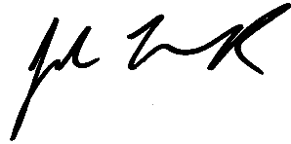
ASSESSMENT BY: John Fitzpatrick SIGNATURE: DATE: 17/06/2022

