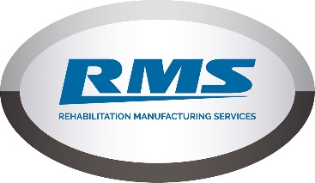**RISK ASSESSMENT**

**Exhibition / Event:** PMG Conference **Venue:** International Centre Telford **Date:** 11th to 13th July 2022

**On Site Contact:** Mila Newbold **Mobile No:** 07454 110530 **Email:** mila@rms-rehab.co.uk

|  |  |  |  |  |  |
| --- | --- | --- | --- | --- | --- |
| **Potential Hazard Identified** | **Consequences** | **Persons**  **at Risk** | **Worst Case Outcome** | **Probability Rating** | **Control**  **Measures** |
| Erection of stand | Possible dropping of equipment or straining of muscles. | RMS Staff | Minor Injury | Low | Use transporters and equipment with wheels where possible. Construct stand with more than one member of staff present to share lifting loads. |
| Dismantling stand | Possible dropping of equipment or straining of muscles. | RMS Staff | Minor Injury | Low | Use transporters and equipment with wheels where possible. Deconstruct stand with more than one member of staff present to share lifting loads |
| Electrical Light Fittings | Electrocution or burning on hot bulbs. | RMS Staff | Minor Injury | Low | RMS have replaced all light fittings with ‘low-heat’ LED bulbs. All equipment safety checked prior to exhibition. |
| Manual Handling | Danger of Slips, Trips, Falls and Strains | RMS Staff | Minor Injury | Low | Manual handling training provide by RMS as standard prior to the event to be adhered to at all times. |
| Free Standing Displays | Risk of falling or being knocked over | RMS Staff and Attendees | Minor Injury | Low | Equipment to be checked prior to the event, stable bases provided for all free standing displays with visual checks on stability throughout the event. |
| Carpets | Trip or Fall Hazard | RMS Staff and Attendees | Minor Injury | Low | Carpets will be fitted by professional carpet fitters prior to the event. If disintegration is noticed it will be reported immediately. |
| Fire Risks | Possible fire or smoke breaking out | RMS Staff and Attendees | Minor Injury | Low | Electrical equipment to be safety checked prior to exhibition. No naked flames or heater will be allowed in our exhibition area. |
| Allergies | Users having an allergic reaction | Attendees | Minor to Major Reaction | Low | While RMS traditionally give out sweets at exhibitions, we will actively avoid any with nuts. Parent/carers permission to be given before sweets can be given out. |
| Other Emergencies | An emergency happening outside our control (e.g. Fire Alarm) | RMS Staff | Minor or Major Injury | Low | All RMS staff attending the show will be given prior access to all show information regarding health and safety and fire escapes. |