Exhibition and Sponsorship Booking Form

**To assist you with your stand selection, please use the information provided in the below table and the floorplan on the following page. Stands highlighted in red have already been reserved for our confirmed sponsors – Southwest Seating & Rehab Ltd, Blatchford and Ki Mobility; also Go Kids Go who will be running the wheelchair testing area, and BHTA.**

|  |
| --- |
| **Stand Prices** |

**£190.00 + VAT per sqm**

Price includes shell scheme, carpet, lighting and power (approx. 2 x spotlights and 1 x 500w power socket per 6sqm).

|  |  |  |
| --- | --- | --- |
| **Stand Number** | **Stand Size** | **Total Cost (excl VAT)** |
| Stands 3 & 49 | 4 sqm | £760.00 |
| Stands 1, 1a, 2, 4, 5, 6, 15, 18, 19, 46, 47 | 6 sqm | £1,140.00 |
| Stand 48 | 7 sqm | £1,330.00 |
| Stands 16, 30, 31, 45, 50 | 8 sqm | £1,520.00 |
| Stands 7a, 20, 21, 29, 41, 42, 43, 44, 51 | 9 sqm | £1,710.00 |
| Stands 7, 24, 33, 34, 35, 36, 38 | 12 sqm | £2,280.00 |
| Stand 27 | 14 sqm | £2,660.00 |
| Stand 25 | 16 sqm | £3,040.00 |
| Stands 23, 53, 54 | 18 sqm | £3,420.00 |
| Stands 11 & 17 | 20 sqm | £3,800.00 |
| Stands 8, 9, 22, 32, 37, 40 | 24 sqm | £4,560.00 |
| Stand 12 | 30 sqm | £5,700.00 |
| Stands 10 & 52 | 48 sqm | £9,120.00 |

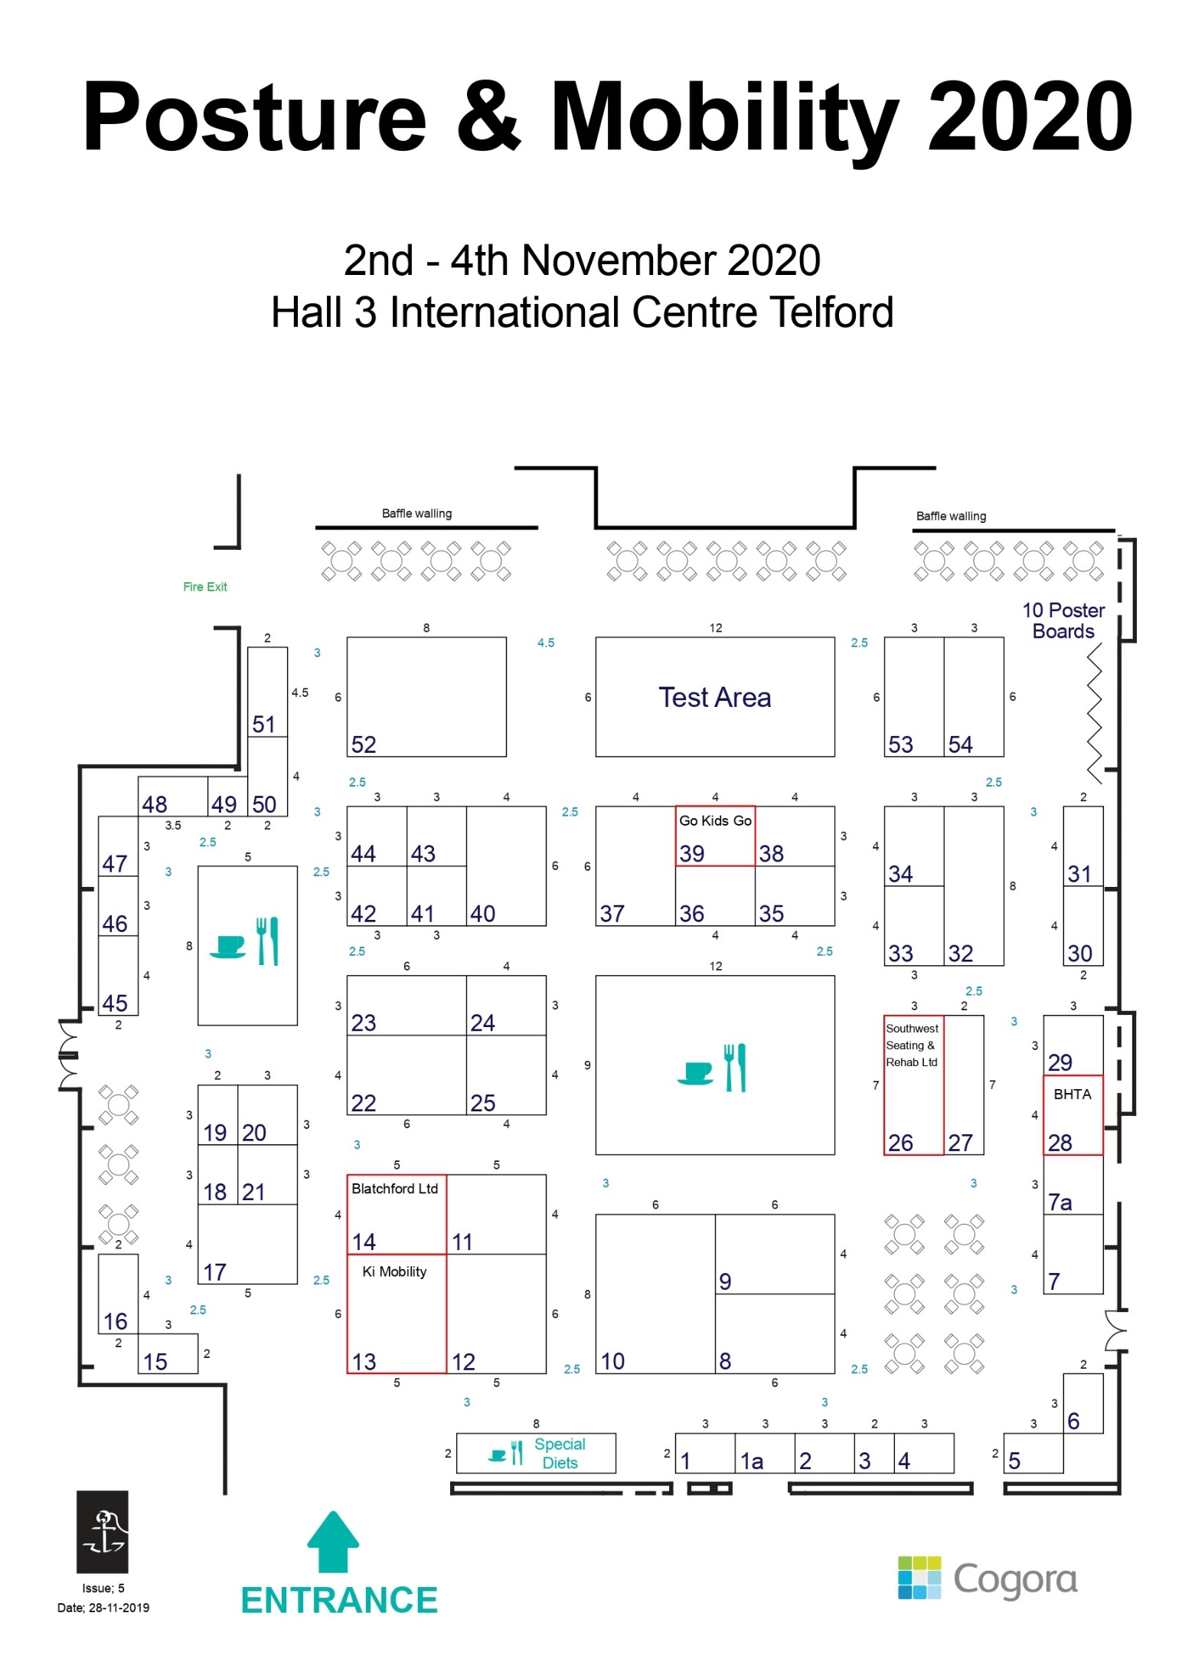

|  |  |
| --- | --- |
| **Company Details** | |
| Contact name: | |
| Position within company: | |
| Company name: | |
| Address: | |
|  | |
|  | |
|  | |
|  | Postcode: |
| Tel: | Mobile: |
| E-mail: | |
| Registration VAT number: | |

|  |  |  |  |
| --- | --- | --- | --- |
| **Exhibition Space** | | | |
| **Choice** | **Stand number(s):** | **Stand sqm:** | **Cost (excl VAT):** |
| First choice |  |  |  |
| Second choice |  |  |  |
| Third choice |  |  |  |

|  |  |  |
| --- | --- | --- |
| **On-site Sponsorship Items** | | |
| **Item** | **Cost** | **Please tick to select** |
| Flyer within conference bag | £300.00 + VAT |  |

|  |
| --- |
| **Invoicing Details** |
| Please send me a VAT invoice quoting Purchas Order Number (*if required*): …………………………………………………………..  Company name and invoice address **if different** from above: ……..........................................................................................................................................................................................................................................................................................................................................................................  **Payment terms:**  Payment must be received within 30 days of the invoice date, or prior to the commencement of the conference, whichever is the sooner. |
| Please return this form to:  Vera Hide  The Conference Collective Ltd, 8 Waldegrave Road, Teddington, TW11 8HT  T: +44 (0) 20 8977 7997  @: [pmgbookings@conferencecollective.co.uk](mailto:pmgbookings@conferencecollective.co.uk) |

|  |  |  |
| --- | --- | --- |
| **Total for Invoice** | | |
| Stand (insert number) |  | **£** |
| Sponsorship items (*if applicable*) |  | **£** |
| **Total (excl VAT)** |  | **£** |

**EXHIBITION AND SPONSORSHIP TERMS AND CONDITIONS**

### **Agreement**

The Booking Form constitutes only an offer by the Sponsor or Exhibitor to exhibit at/sponsor PMG Conference 2020 on these terms and conditions only. The Organisers reserve the right to accept or refuse such offer at its sole discretion. In the event that the Organisers accept the Sponsor’s/Exhibitor’s offer, the Organiser will provide written confirmation of the booking and this will create a legally binding contract between the Sponsor and the Organiser on these terms and conditions only to the exclusion of all others (this ‘Agreement’).

All bookings of exhibition packages and sponsorship are administered on a first-come, first-served basis. A completed Exhibition/Sponsorship Booking Form should be posted/emailed to ensure reservation of a desired location. Upon receipt of the Exhibition Booking Form, space will be confirmed, and an invoice will be emailed. Please note that three choices in order of preference should be clearly indicated on the application form. Stand allocations will be made in the order in which application forms are received.   
**Payment**

On providing such written confirmation to the Exhibitor/Sponsor, the Organiser will issue its invoice to the Exhibitor/Sponsor in respect of the Exhibitor/Sponsorship Fee. The Exhibitor/Sponsor shall make full and final payment to the Organiser no later than 30 days following receipt of the invoice or by the first day of the Conference, whichever comes first. All Exhibitor/Sponsorship Fees are subject to VAT at the prevailing rate. Payments should be made in Pounds Sterling and made payable to ‘Posture and Mobility Group, c/o The Conference Collective Ltd.

### **Terms**

This Agreement commences on the date of the Organiser’s written confirmation of the booking and shall terminate at the end of the PMG Conference 2020 except when expressly provided otherwise in these terms.

**Cancellation Clause**

Organisation’s booking a stand at the PMG Conference must not hold training events that take place during the educational programme/exhibition opening hours of the conference (generally Tuesday and Wednesday 8am-5pm). If PMG learns of such training events, and these are not rearranged, we reserve the right to cancel your stand booking, in which case we will provide a full refund.

Training events are welcomed on the set-up day of the exhibition; PMG will not assist in the organisation of these additional events, but will market them using the usual routes (our [External Training Event](https://www.pmguk.co.uk/training/external-training-events) listings, social media and emails to mailing list) if requested, as long as they are relevant to PMG's membership.

All exhibitors must abide by any rules set out in the Exhibitor Manual, and follow any instructions given regarding health & safety, shell scheme, set-up/break-down and traffic management by PMG/venue staff and/or our contractors. Failure to do so may result in you being refused entry to the exhibition.

**Refund Policy**

If you decide that you no longer wish to exhibit at our event, you will not be entitled to a refund for your stand booking. Where the exhibition is fully booked, and we are able to resell the stand to another company, we may provide a refund for your booking.

In the event that the exhibition is cancelled, rescheduled or changes venue, you will be entitled to a full refund for the value of your stand and any sponsorship fees. However, PMG is not liable for any additional costs paid to third parties in relation to the event, such as graphic design or stand fittings.

### **The Organiser’s Obligations**

The Organiser will:

* Organise PMG Conference 2020 to a high standard and to the best of its ability.
* Not do or knowingly permit to be done anything which is prejudicial to the good image of the Exhibitor/Sponsor.

**Exhibitors/Sponsors Obligations**

Stands must be staffed during exhibition times, including refreshment breaks, lunch breaks and poster viewing sessions.   
**Insurance**

While every precaution is taken to protect your property during the event, the Organisers are not responsible for any loss or damage and we strongly recommend that you take out appropriate insurance cover. The Organisers accept no responsibility for any loss sustained by exhibitors from theft, fire damage or any third party.

Exhibitors are also responsible for insuring against any legal liability incurred in respect of injury or damage to property belonging to third parties. In addition to this, exhibitors should protect their expenditures against abandonment and cancellation or curtailment of the event due to reasons beyond the Organiser’s control.

**Security**

The Organisers cannot be held responsible for the loss or damage to exhibitors’ property. Exhibitors/Sponsors are advised not to leave their stand unattended at any time especially if there are portable and valuable items on the stand.

**Exhibition Set Up and Breakdown**

Exhibitors must ensure that their stand is set up and dressed by the times specified in the Exhibitor Manual. The only activities permissible on the days of the Conference are displaying brochures or the set up of any valuable equipment, which for security reasons you do not want to leave unattended overnight. Exhibition stands must not be broken down before (15:30) on Wednesday 4 November 2020, the last day of the Conference. Please note, the above time is subject to change.

**Exhibitors’ Responsibilities**

All exhibiting companies are responsible for their stand. Due consideration must be given to the safety of the stand throughout the event and that any actions or inactions do not give rise to accidents, injuries or an unsafe working environment so far as is reasonably practicable.

**Accessibility**

The current EU regulations state that disabled persons must be afforded the same opportunities as non-disabled persons. This includes the ability to attend exhibitions and view any exhibits. To this end, exhibitors are advised to ensure that their stand is easily accessible to visitors in wheelchairs.

**Liability Clause**

The Organiser shall not be liable for any failure to fufill this contract where failure is caused by supervening circumstances including weather, fire, flood, earthquake, transport delays, war, riots, acts of terrorism or event which, without fault of either party, render fulfilment impossible.