PMG Conference: A one stop shop by Alfred Mangundu

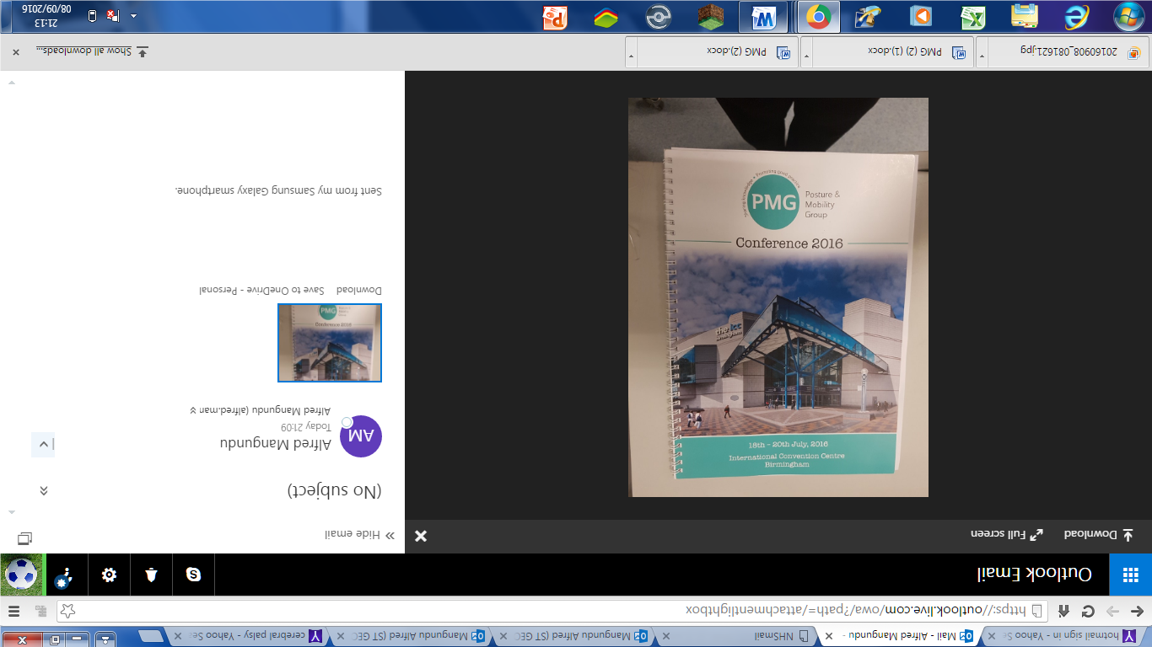

As a Rehabilitation Engineer I have been involved in the provision of cost effective solutions (equipment) to people with posture and mobility problems for the past two years. I qualified as an engineer in 2014 from Coventry University. During my placements I was fortunate to be mentored by Engineers and therapists from the West Midlands. One of the highlights that everyone used to look forward to was the PMG conference. During my first year of employment I applied to attend the PMG conference in 2015 but narrowly missed on a chance secure to secure a place as training budgets were being tightened.

This year with the conference being held in Birmingham I was looking forward to it. Although my supervisor had encouraged me to apply for a bursary place I was not sure whether my application was going to be successful. As I was determined to attend I decided to also apply to attend as a day visitor as this was guaranteed. I was so grateful to the PMG team when I received an email confirming that my application was successful and I would be able to attend whole conference. For me as I reflect about my experiences after attending the conference PMG conference 2016 was a one stop shop.

The three days were packed with different activities. It was a time for networking, learning practical ways of providing posture and mobility solutions to real life problems, being inspired and challenged. I made sure that I visited most of the stands where different companies were exhibiting their products to learn about any product updates, new products and got clarifications on technical issues I had encountered in my day to day work. Clients have been assessed for some of the new equipment that was on display at PMG.

The speed networking event started the ball rolling although I was initially not sure what was involved. In one of the sessions professionals were discussing about head supports. One of the solutions suggested for some complex clients was to supply headrest to meet the different activities for clients as almost everyone agreed that sometimes there were different issues when adjustments made by carers/parents for example when the same headrest was to be used in a relaxed seating position at home and when feeding or in transport. A few days after the conference I was in a visit with a client diagnosed with MND who I think would benefit from such an arrangement. Alternative head supports are to be assessed and trialled.

Case studies on the use of switches drive electric wheelchairs highlighted the difference that thinking outside the box can make to promote independence of people with posture and mobility problems. The first case study by V. Curling and R. Hindle, involved a five year old diagnosed with spinal muscular atrophy using fibre optic switches to drive a power chair. No force is used to activate the switches and can be used with clients with limited movement of fingers. In the second case study a bespoke switch for driving a wheelchair was developed by J. Salami. This involved a foot switch that can distinguish between voluntary and involuntary movement to be used by a client diagnosed with dystonic cerebral palsy (CP) to control a wheelchair. Clients with this type of CP are susceptible to muscle spasms and contractions which make it almost impossible to use other (standard) wheelchair controls. These are some of the first cases I have encountered where someone had successfully used these types of switches.

Legal guidelines were also given in the presentation on safety, equipment, restraint: mental capacity and human rights by M.Mandelstam. I have found the use posture belts and harnesses in relation to restraint challenging especially for occasional wheelchair users. I am now better informed knowing that the legal test is about the decision making process and justification rather than the decision or action made.

I also attended the presentation: Making life better: postural management & surgery for the child and adult with complex disability by M. Gough and W. Murphy. It was highlighted that any intervention should aim to improve function and comfort and enhance participation. The use of posture management in the prevention of hip dislocations was discussed and a lively debate ensued. During the debate I learnt that not only is weight bearing necessary for the development of the hip joint but one has to consider both muscle and brain activity. Stabilising the pelvis is one of the fundamentals of good posture control but the ideal position of the legs raised a lot of questions as whether the legs should be in adduction or abduction when providing postural support. Some of the issues discussed by experienced professionals who were making recollections (or comparisons) of presentations made at previous PMG conferences highlighted the need for me as a professional to have an open mind and continue to develop my knowledge base.

I would have loved to attend most of the presentations but this was not possible in just two days. I am so grateful for the PMG bursary that enabled me to attend all the activities of this year’s well organised conference. Almost everything I would need in my professional development provided in one event. This really was an appetiser for me and would strive to attend future PMG conferences.