Microsoft PowerPoint 2007 for posters
— filed under: Communicating your research, Presentation, Resources
IT workbook

1. Introduction
Microsoft PowerPoint (‘PowerPoint’) is well known as a presentation application; used for both creating and delivering visual elements in support of presentations. However, it can also be used to create academic posters (as recommended by the University’s Design Services) as it is a format that many people are already familiar with, having used it for on-screen presentations.
Remember that however good the visual appearance of a presentation or poster is it can’t disguise poor content. So, whilst the visual quality of a presentation or poster is important, this should be secondary to the actual content; the content should inform the design, not the other way around.

1.1. Notation used throughout this document
Ribbon commands are written, e.g. Home | Slides | New Slide, this means select the Home Tab and within the Slides Group of the Ribbon, select New Slide option. All key presses are included within < > e.g. <Enter> means press the Enter key. <Ctrl A> means hold down the Control key and press the A key.
When the Office Button is referred to, this is the circular button in the top left hand corner (Figure 1).

Figure 1: Office Button

1.2. Use of this document
This guide is to supplement face-to-face training but can also be used as a self-directed resource. You can also access resources on the design aspects of creating a poster and templates here.

1.3. Sample files
This guide refers to a sample file which is available here.
If you have any questions or comments about this documents please contact Stuart Johnson.

2. Layout
It is important to get the layout of your poster correct at an early stage.

2.1. Page setup
The first thing to get right when using PowerPoint to create posters is the page setup. Because PowerPoint is primarily used as an on-screen presenting application the default page setup for slides is ‘On-screen show’. This needs to be changed to suit a paper-based output.
- Open up a new presentation in PowerPoint.
- Go to Design | Page Setup | Page Setup.
- You will see that it says ‘Slides sized for: On-screen show’ – change this to A4 Paper (210x297mm) from the drop-down list.
- Notice that the ‘Width’ and ‘Height’ boxes now say 27.51 cm and 19.05 cm respectively; this is because PowerPoint has put a border around the slide for you. However, you don’t want a border because it is going to be printed out on A1 or A0 and a small border in A4 will create a much larger border in A0, so…
- Change the width to 29.7cm and the height to 21cm – you will notice that the ‘Slides sized for’ now reads ‘Custom (Figure 2).
- Choose the appropriate slide orientation – portrait or landscape.
- Click ‘OK’.
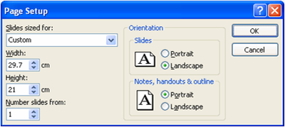
Figure 2: Page Setup

2.2. Slide layout
Next make sure that the slide layout is set to ‘Blank’. This can be done from Home | Slides | Layout (Figure 3).
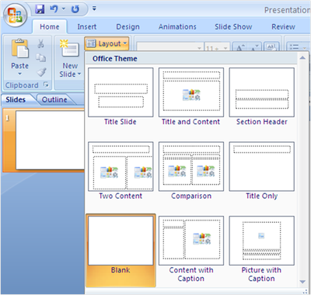
Figure 3: Slide Layout pane

2.3. Grids and guides
Placing objects (e.g. pictures, charts, text boxes) within PowerPoint can be a little tricky, this is due to the ‘Grids and Guides’ feature, but it can also be solved using the Grids and Guides feature. To access the Grids and Guides go to Home | Drawing | Arrange | Align | Grid Settings (Figure 4). You will see a number of options; ‘Snap to’, ‘Grid settings’ and ‘Guide settings’.
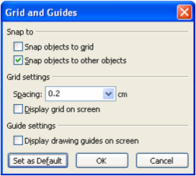
Figure 4: Grids and Guides
- Open the file poster_sample.pptx.
- Go to the slide titled ‘Grids and guides’.
- Try and accurately place the red and yellow triangles in the box to form a square.
It is difficult to line up the triangles because the check box ‘Snap objects to other objects’ is not selected. So…
- Go to Home | Drawing | Arrange | Align | Grid Settings.
- Check the box ‘Snap objects to other objects’.
- Click ‘OK’.
- Now try lining up the triangles to form a square again.
Now see what the other check boxes do…
- Go to Home | Drawing | Arrange | Align | Grid Settings.
- Check the box ‘Display grid on screen’.
- Click ‘OK’.
- Go to Home | Drawing | Arrange | Align | Grid Settings.
- Uncheck the box ‘Display grid on screen’.
- Check the box ‘Display drawing guides on screen’.
- Click ‘OK’.
- You can get additional drawing guides by holding down the Control key <Ctrl> and dragging one of the guides. This can be useful when creating a template for your poster.

3. Text
Text is an important element of any poster.

3.1. Line spacing
Increasing the line spacing of small text can make it more readable.
- Open the file poster_sample.pptx.
- Go to the slide titled ‘My poster’.
- Select all the text in the text box by clicking on the border of the text box.
- Go to Home | Paragraph | Spacing | Line Spacing | Line Spacing.
- Change the change the Line spacing to 1.1 and the Before paragraph to 6 pt. (Figure 5).
- Click ‘OK’.
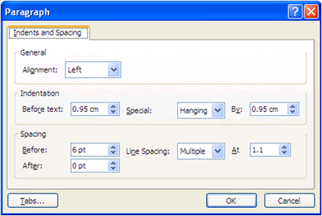
Figure 5: Line Spacing

3.2. Text boxes
Text boxes in PowerPoint default to re-sizing to fit the text. You may wish to create a text box that is bigger than the text to help with the layout, in which case the text box re-sizing needs to be switched off.
- Go to the slide ‘Text boxes’.
- Go to Insert | Text | Text box (or use the button on the Drawing Toolbar).
- Type some text in the text box.
- Use the grab points to try and increase the height of the text box (it doesn’t – only the width will re-size).
- Right click on the border of the text box and choose Format Shape.
- Select the Text Box tab.
- Uncheck Resize AutoShape to fit text.
- Click ‘OK’.
- Use the grab points on the edges of the text box to re-size it to an appropriate size – you will notice that if you make the text box too narrow the text will spill over the edge of the box.
- Follow steps 5-6 above and then check Word wrap text in AutoShape.

3.3. Adding text to objects
If you want to add text to an object, e.g. a shape, there are a number of ways to do this, but the most straightforward is simply to right click on the object and choose Edit Text (Figure 6).
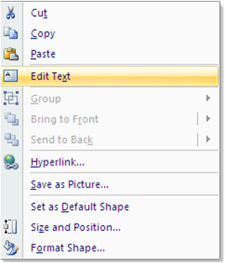
Figure 6: Adding text to an object

4. Images
Images are the other key element of poster design.

4.1. Order
Sometimes you will want objects to overlap other objects. In PowerPoint the order of these ‘layers’ is determined by the order the objects are inserted into a slide; so the most recently pasted object will always be on top. However, you may want to change the order of the layering. You can do this by sending objects forwards and backwards using the order feature (Figure 7).
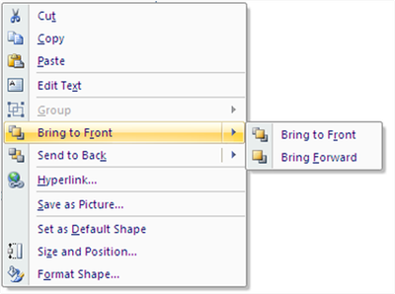
Figure 7: Order
- Go to the slide ‘Order’.
- Drag and drop the white arrow over the blue shape (the white arrow will be hidden underneath).
- Right click the blue shape then choose Send to Back | Send Backwards.

4.2. Image resolution
One of the key things to remember when using PowerPoint to create Posters is to choose images of an appropriate resolution. If you are designing in A4 and enlarging to A1 or A0 then the images quality is going to decrease, it is therefore important that you use the highest resolution practically possible for your images (300 ppi or greater).

4.3. Inserting images
When placing images in a PowerPoint file where image quality is important (i.e. posters) make sure that you don’t use the Office Clipboard as this will also cause image quality to decrease; instead insert all images as picture files.
- Go to www.compfight.com.
- Choose ‘Creative Commons: Only’.
- Search for an appropriate image (try ‘tree’).
- Scroll down to ‘Additional information’ and click on ‘Some right reserved’ to check the type of Creative Commons Licence.
- Go back to the image – right click it and choose, ‘Save image as’
- Go to the slide ‘Inserting images’.
- Go to Insert | Illustrations | Picture.
- Find the saved picture, select it then click Insert.
- Attribute the work in the manner specified by the author.

4.4. Rotating images
There are a number of ways to rotate an image in PowerPoint. You can simply click the image and then hover over the green dot at the top of the image and rotate the image free-hand. Alternatively, if you need to be more precise you can right click the image and chose Size and Position… (Figure 8).
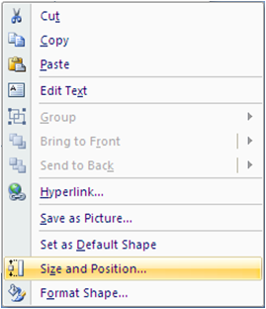
Figure 8: Format Picture
Then choose the Size tab from the Size and Position window and change the number in the rotation box (Figure 9).
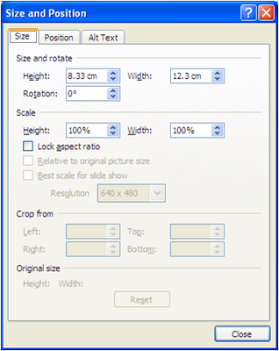
Figure 9: Rotation
A third way is to go to Picture Tools | Arrange | Rotate (Figure 10). This has the advantage of having a number of pre-set options.
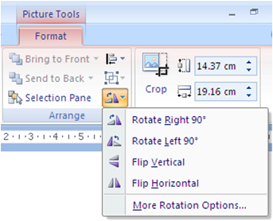
Figure 10: Rotate or Flip

4.5. Re-sizing images
Depending on the type of the image, it may be possible to distort the proportions of the image, e.g.:
Figure 11: Distorted image
The example above is an obvious one but sometimes it is less obvious, therefore you need to be careful to ensure that when you resize an image you don’t introduce distortion unintentionally. You can ensure this by clicking on the image and then resizing it from its corners rather than from the sides, top or bottom. Alternatively you can right click the image then select ‘Format Picture’.
- Go to the slide ‘Re-sizing images’.
- Right click the image then choose Size and Position...
- Go to the Size tab.
- Change the height to 75%.
- Ensure Lock aspect ratio is checked (this will mean the width will also change to 75% automatically).
- Click ‘OK’

4.6. Aligning and distributing images
Aligning and distributing images can be a bit fiddly. You can save yourself a lot of time and be much more accurate suing the Align or Distribute feature from the Draw menu.
- Go to the slide ‘Align or distribute’.
- Select all 5 arrows.
- Go to Drawing Tools | Arrange | Align | Align Top (Figure 12)
- Then (keeping the arrows selected) Align or Distribute | Distribute Horizontally (Figure 13).
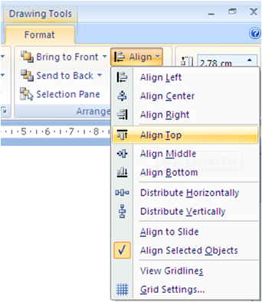
Figure 12: Aligning
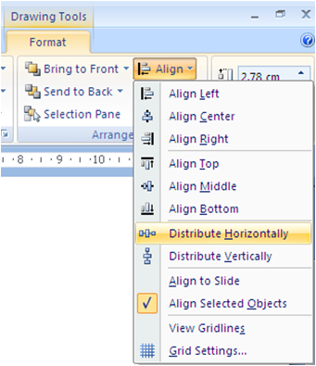
Figure 13: Distributing

4.7. Picture Tools
The Picture Tools (Figure 14) has a range of very useful features as follows:
- colour;
- more/less contrast;
- more/less brightness;
- crop;
- rotate;
- line style;
- compress picture;
- text wrapping;
- format picture;
- set transparent colour;
- re-set picture.
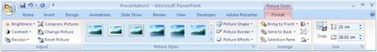
Figure 14: Picture ribbon

