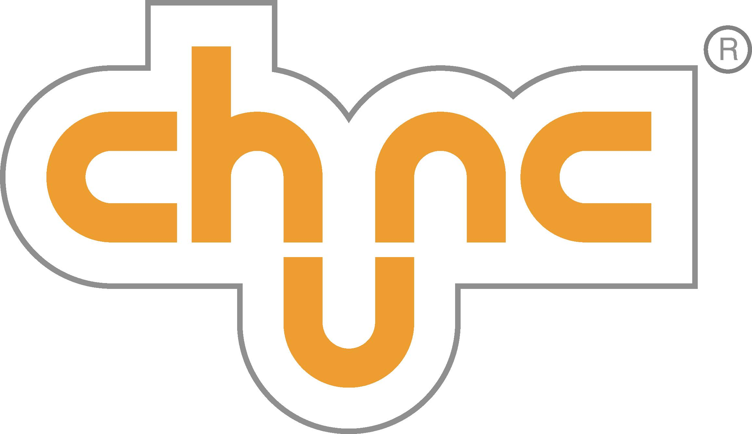

Chunc Posture and Mobility for young people

Sales Team member for:

Yorkshire,Cleveland,Durham,Northumberland,
Humberside,Tyne and Wear

This new opportunity has come about due the continued growth in our business.

You will be joining a growing business, we will ask you to contribute to the future success in a number of different ways:

You will be able to make significant differences to young people’s lives. Dealing directly with our clients and in conjunction with healthcare professionals carry out joint assessments to provide the best solutions

You will contribute towards the development and improvement of the Chunc brand going forward with feedback from your experiences in the field; this will be valued and appreciated.

In addition you will have the opportunity to present and demonstrate the Chunc brand at In-service clinics and other facilities as well attending Exhibitions and Trade Shows.

To join us you will need to have a successful background as in Rehabilitation Engineering services/Physiotherapy/Occupational Therapy sectors.

Home based, ideally located in the region where your responsibility lies.

Highly organized, you have the ability to develop successful working relationships. Confident when training, demonstrating and presenting you are driven, results orientated and keen to go the ‘extra step’ to achieve

For further information or to apply please send your C.V to sales@chunc.co.uk for the attention of Tim Dines Business Development Manager.

