LEVELS OF INPUT AND EXPERTISE NEEDED
FOR WHEELCHAIR SERVICE PROVISION

Compiled from information prepared and gathered by members of the
Posture and Mobility Group
Edited by: Carolyn Nichols MCSP
PMG Executive Committee member and Editor, PMG journal

The following is from Specialised Services National Definitions Set, Definition No.5: Assessment and Provision of Equipment for People with Complex Physical Disabilities (all ages) (3rd Edition):

The specialised wheelchair service is identified by the complexity of the individual’s condition and not by specific pieces of equipment. It is the complexity and severity of the person’s condition, and the expertise required to assess/support and provide/maintain equipment for each individual that defines a specialised equipment service as opposed to the nature of the equipment itself.

Specialised equipment services are characterised by:
• the complexity of service user needs (complex physical/cognitive/language/sensory disability - often in combination)
• expert assessment
• user and carer training to maximise effectiveness and independence
• timely review and re-assessment for changing needs
• on-going, life-long maintenance/replacement and user support.
Specialised wheelchair services are required by people who meet the following criteria:
• individuals whose posture or mobility needs can only be met with a high level of specific design input resulting in unique prescriptions which may use combinations of bespoke and/or off the shelf components; consideration of static seating and 24-hour postural management systems may also be required to ensure optimal outcomes
• individuals whose posture and mobility needs may not be complex in their own right but nevertheless significantly impinge on the overall level of functional ability
• individuals who have the ability to control a powered wheelchair but are unable to use standard joystick controls
• individuals requiring multiple items of equipment integrated via the wheelchair control methods.

LEVELS OF COMPLEXITY
(combining work done by Linda Marks, Lisa Ledger, Dave Long, and others)
(Short-term / occasional users, as is currently the case, are considered “ineligible”.)
- Straightforward cases: This describes individuals who have a relatively simple need who can largely be self supporting. With regard to wheelchair provision at this level, individuals could be assessed by a ‘trusted assessor’ with core basic assessment skills and competency in wheelchair prescription. Provision could then be through a number of options, including the use of personal health budgets or a voucher type option for use at any ‘approved retailer’ outlet. The need is likely to be one off, simplistic, and would not require review in a clinical sense; the individual could also be given general advice around related health aspects such as maintenance of healthy skin and good posture care.

- Moderate cases: A large proportion of wheelchair users would likely fall in this category, where assessment would need to be more specialist and clinically focused, with skills around management of a condition including tissue viability, posture care and more specialist wheelchair and seating options. Individuals at this level require regular review and inter-agency liaison and involvement within a care pathway approach. A robust clinical interface is essential at this level so that timely and appropriate intervention can occur to prevent individuals moving up the triangle. At this level, it is unlikely that equipment will be the only provision, but rather specialist advice, information, therapy, medical management to name a few of the related responses that may be indicated. Therefore, at this level the ‘equipment’ component cannot be separated from the clinical assessment and handover/delivery components. An example of this level would be an individual who uses their wheelchair on a full-time basis and requires a degree of postural support in the form of a contoured cushion and backrest. This type of equipment would need to be set up to the individual user’s posture, lifestyle and mobility requirements, thus requiring a clinician to be involved at handover/fitting stage.

- Complex cases: These are individuals who have highly complex requirements and are at greatest risk to their health and well being. As in level 2, the response here regarding wheelchair provision must be met within a specialist service and as part of the multi-disciplinary, interagency team. These individuals are at high risk of secondary complications due to their level of disability, such as pressure ulcers, contractures, chest infections and respiratory illness and may require an individual bespoke equipment solution. Regular review and a timely response are crucial at this level using a case-management type response. In this sense, ‘any qualified provider’ would need to be clinically focused with proven expert specialist skills and competencies within the field of wheelchairs, tissue viability and posture management.

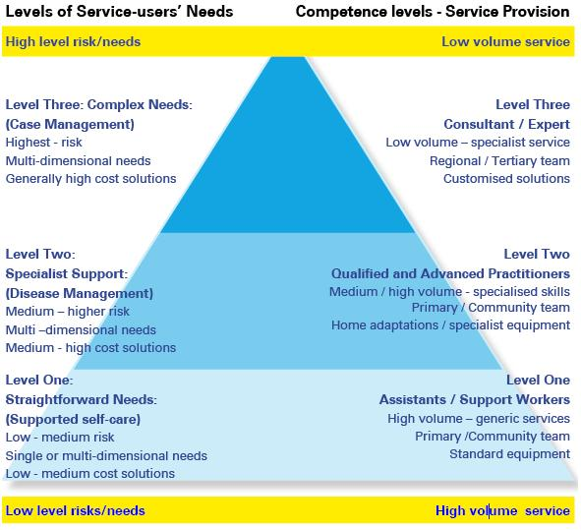
(above extracted from: Wheelchair and Specialist Seating Services: A Clinical Guide for Commissioners and Provider Services, Lisa Jayne Ledger)

INDICATORS OF LEVEL OF INPUT REQUIRED:
Description of Indicator: | Level
Time
Wheelchair is a mobility option but used <1hr /day | 1
Wheelchair is main means of mobility, used every day but not all day | 1 or 2
Totally dependent on wheelchair for mobility and in it all day | 2 or 3

Posture
No specific postural issues | 1
Requires a single commercial postural support e.g. backrest, cushion, wedge, lateral supports | 1 or 2
Requires 2 or more postural elements which can be commercial or bespoke | 2 or 3
Needs complete postural support requiring bespoke prescription | 2 or 3

Ability to establish, maintain, and change position
Can change position independently | 1
Can change position with occasional assistance/prompting/supervision | 1 or 2
Can change position with regular assistance of one person | 2 or 3
Poor ability to establish a good sitting position, even with assistance | 2 or 3
Totally dependent on one or more people in order to change position | 2 or 3
Spasticity and/or involuntary movements are present, causing difficulties with establishing and maintaining a good sitting position, even with assistance | 2 or 3
Recurrent issues with pressure ulceration | 3

Need for assistive technology
Requires basic manual chair (attendant or self propelled) only | 1
Requires powered chair for mobility | 2 or 3
Requires lightweight, active user chair | 2 or 3
Requires powered chair and one or more additional assistive technology (AT) devices to enhance independence and quality of life | 2 or 3
Totally dependent on powered chair with multiple integrated AT devices, to maintain quality of life | 3

Changing needs
Static condition | 1
Anticipated, predictable change requiring regular monitoring and adjustment e.g. as a result of growth, injury, surgery, lifestyle change | 2 or 3
Single anticipated change but with unpredictable needs e.g. surgery | 2 or 3
Continual anticipated changes, with unpredictable needs e.g. deteriorating conditions | 3

Additional specific indicators of clients who need level 3 / specialist services:
- Clients with specific diagnoses who are totally dependent: cerebral palsy, muscular dystrophy, motor neurone disease, multiple sclerosis, and other progressive, deteriorating neurological conditions
- A person with a progressive neurological condition with moderate postural need who would ideally be prescribed a tilting powered wheelchair but who is unable to drive safely. Since they need to maintain independence in the day time while their spouse is out at work, a normal self propelling manual wheelchair with customised supports is prescribed. This example highlights the need of the clinician to make judgements where a number of conflicting factors exist but where, ultimately, the equipment prescribed is, on the face of it, non-complex.

- A person having a movement disorder where there are significant amounts of involuntary movement causing premature failure of “off the shelf” equipment. This sort of prescription requires very careful consideration and experience in determining what equipment has sufficient strength and function to meet the requirements.

- A person who has a very high level of postural need normally leading to the prescription of custom contoured seating but who chooses to use “off the shelf” equipment for functional reasons. This sort of assessment must be equally as thorough as an assessment in which the person is prescribed custom contoured seating in order to provide sufficient information for a sound, clinical decision to be made.

- A person with a moderate to low postural requirement but who has a highly complex and intricate combination of functional, environmental, and social factors for whom only a very specific piece of “off the shelf” equipment will be appropriate, i.e. the person carrying out the assessment must be able to appraise a wide variety of options, including custom made equipment, before deciding on a prescription.

- A person having recurrent issues with pressure ulceration should be referred to the specialist service because, usually, the problems are not isolated to the wheelchair and may require changes in routine, other equipment, and nursing input.

- A person who would be adequately supported by “off the shelf” equipment but who continues to experience significant and chronic pain.

- A person having “challenging behaviour” where there are significant issues balancing the need for safety with the risk of applying restraint.

