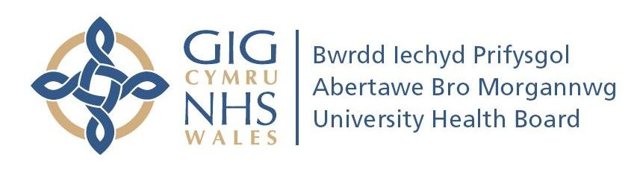
Head of Rehabilitation Engineering
Morriston Hospital, Swansea
Band 8D: £65,270-£80,810 p.a.

We are seeking a highly-motivated and experienced individual to lead the Rehabilitation Engineering Services for South West Wales and to sustain the momentum of innovation and service development.

The Rehabilitation Engineering Unit (Department of Medical Physics & Clinical Engineering) is staffed by 3 Clinical Scientists, 6 Clinical Technologists, 2 Woundcare Specialist Nurses and 3 Administrative support staff. The Unit provides services in special seating/postural management using the latest digital scanning and CAM processes, pressure ulcer prevention and intervention (PUPIS), assistive technology and functional electrical stimulation.
The Unit is part of the All-Wales Training Consortium for Clinical Scientists in Rehabilitation Engineering and the Head of Unit is expected to lead this activity. In addition, the Unit has been very active in clinically-focused research and development, in particular in collaboration with Swansea University, and has attracted considerable project funding. A strong track record in research and development, teaching and project supervision is desirable. For a candidate otherwise suitably qualified, but who lacks a strong academic track record, appointment may be offered at Band 8C.
For informal enquiries, please contact Director of Medical Physics & Clinical Engineering, Professor Huw Griffiths, tel: 01792 285297, email huw.griffiths5@wales.nhs.uk.

To apply for the post, visit https://www.jobs.nhs.uk (Job Ref. 130-HS009-1112).

Closing date: 24/12/12

