APOLOGIA

The article Development of an Objective Measurement System to assist in Wheelchair Seating Prescription was published in issue 28:2 of the PMG journal, and we omitted to publish the names of the co-authors. We wish to apologise to all concerned, and are publishing the article in full here to go some way to rectifying the error.

Development of an Objective Measurement System to assist in Wheelchair Seating Prescription

Carwyn Jones,† S. Sadani,* B. Bhakta,§ A. Seal,‡ R. Hall^{α} and M. Levesley^{β}

† PhD Research Engineer,
* Specialist Registrar in Paediatrics,
§ Professor in Rehabilitation Medicine,
‡ Community Paediatrician,
α Professor of Spinal Biomechanics,
β Professor of Dynamics and Control

ORGANISATIONS
† α β School of Mechanical Engineering, University of Leeds

*Department of Community Paediatrics, Yorkshire and the Humber Deanery & Leeds Teaching Hospitals NHS trust, St James University Hospital

§Academic Department of Rehabilitation Medicine, Faculty of Medicine and Health, University of Leeds & Leeds Teaching Hospitals NHS trust

‡Department of Community Paediatrics, NHS Leeds Community Healthcare

Abstract: Non-ambulant children with Cerebral Palsy (CP) are at a high risk of developing the spinal deformity scoliosis. Supportive seating within wheelchairs is an important postural management technique to encourage healthy growth and improve function. However, currently, the process of seating prescription relies predominantly on the subjective assessment by skilled staff.
This article presents the development of an objective measurement system intended to aid staff in the prescription of seating systems for non-ambulant children with CP.
Key Words: Cerebral Palsy, scoliosis, seating system, measurement
“Cerebral Palsy (CP) is the most common cause of motor disability in young children, it occurs in 2 to 3 per 1000 live births” (Cans. 2000).

In the case of severe CP, non-ambulant individuals are at a higher risk of developing contractures, restricted lung function and spinal scoliosis, particularly during growth periods. Within the UK the primary, non-surgical treatment is 24 hour posture management; this involves passive and active movements along with use of support systems. Wheelchair seating support is an important contributing factor to posture management; however this process currently relies predominantly on the skills and subjective assessment of those prescribing the seat.
Purpose of Research
The purpose of this research was to develop a device to provide objective, quantifiable seating measures to assist in the process of seating prescription. This article describes how relevant stakeholders were involved in the device development to ensure the equipment was useful and appropriate. An initial specification was derived from stakeholder feedback, and a prototype system was developed to assess the spinal curvature of non-ambulant children with CP while seated. The spinal assessments were carried out utilising surface topography technology along with X-rays.
Following this study the device specification was further developed and a Seating Measurement System (SMS) was designed and manufactured to conform to this specification. A more comprehensive clinical investigation was carried out with able bodied and non-ambulant children with CP to compare seating parameters. The final system provided measures of spinal curvature and back shape, pressure and force distribution through the seat, along with an assessment of upper limb function.

Research Methods
To discover what was needed from a system to measure seating parameters a range of suitable stakeholders were involved throughout the development process utilising a ‘User Centred Design’ methodology. These stakeholders were divided into groups: ‘Clinical’, ‘Seating’, ‘Technical’ and ‘Carers and Children’.

The clinical stakeholders involved paediatricians from the Leeds area along with additional academic clinical staff. Seating stakeholders included the physiotherapy and engineering staff in Seacroft Seating Services, Leeds, along with some wheelchair companies including Otto Bock Healthcare plc and Consolor Ltd. Active Design Ltd, Birmingham, provided some components for the research and were involved in numerous extended discussions. Technical stakeholders included engineering staff from within the school of Mechanical Engineering, University of Leeds, associated with the Next Generation Health Care Devices group along with medical photography and radiology staff within Leeds General Infirmary (LGI). Stakeholders within the carers and children group involved able bodied and non-ambulant children with CP along with their respective parents, guardians or alternative care givers.

Initially stakeholders were involved in interviews and discussions to identify the most important parameters that should be considered during seating prescription. Although each group had varying priorities, all groups desired a method to monitor scoliosis. Currently the gold standard for the assessment of spinal deformities is the X-ray (Levy. et al. 2006). The MacKeith consensus on 24 hour postural management of children with CP recommends that spine X-rays should be considered for children with CP in GMFCS group IV and V who are still non-ambulant at age 5 years (Gericke. 2006). However, frequent exposure to radiation has associated health risks, therefore stakeholders preferred a method of spinal assessment during seating prescription that did not use X-rays.

Surface topography is a non-radiological method of assessing spinal curvature. By projecting structured light patterns onto an individual’s back surface, and taking digital images, a 3D map of their back can be derived. If adhesive markers are placed onto the individual’s spinous processes an estimation of their 3D spinal curve can be produced.

Initial Clinical Investigation – Assessment of surface topography
An initial clinical investigation was designed to assess if surface topography was an acceptable alternative to spinal X-rays for non-ambulant children with CP. A modular seating system was developed conforming to requirements presented by the stakeholders. A Quantec Scanner (a surface topography system) was in clinical use within the LGI for standing patients, and the seating system was developed to interface with this existing system along with the X-ray. This required the seat to be designed to support the individual with their spine and some of their back exposed for imaging. To accommodate children with different spinal deformities the seat provided posterior and lateral torso and pelvic support using easily adjustable, lockable mechanisms. The seat could also accommodate children with windswept hips using adjustable foot supports.

Children were provided with comparable seating support within both spinal imaging systems in order for the result to be compared. The Cobb angle is a measure of lateral spinal curvature taken from anterior-posterior X-rays; this value was compared against the equivalent Q-angle taken from the Quantec Scanner for each child. 18 children with CP within GMFCS IV-V (non-ambulant), aged 5-11 years old, were successfully assessed in both spinal imaging systems. To assess the comfort level of children, and the appropriateness of the seating and imaging process, a questionnaire was provided to the carers and children. The seating system within the X-ray and Quantec Scanner is shown in Figure 1.

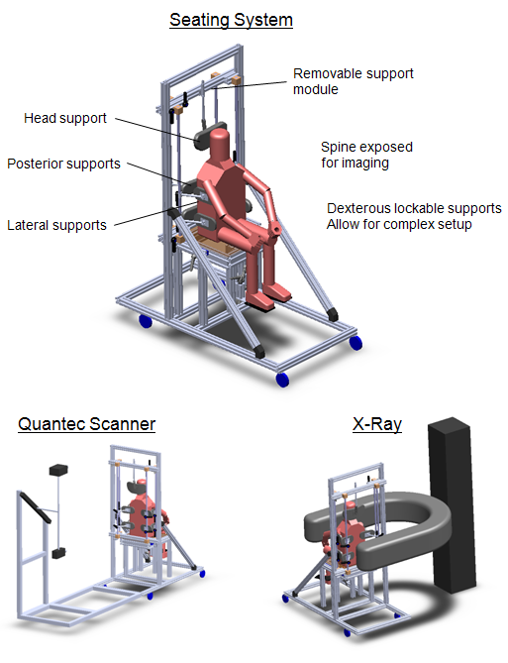

Figure 1: Seating system along with Quantec Scanner and X-ray
Results
With appropriate postural support it was found to be feasible to perform both spinal assessments while individuals were seated. Results indicated that surface topography could provide a similar measure of lateral spinal curvature to X-rays where the differences between the measures were comparable to the variance observed for intra- and inter-observer X-ray studies. 65% of children showed a scoliotic curve in the X-ray examination (scoliosis defined as a Cobb angle greater than 10°), 85% of children had a Cobb angle below 28°, and one child had a 73° Cobb angle. Full details of the results from this study are presented in (Sadani. et al. 2011).

System Development
Based on the results of the initial clinical investigation, surface topography was accepted by stakeholders as a more appropriate method of spinal assessment than X-rays during seating prescription. Stakeholders were involved in further discussions to identify additional important seating parameters and to gather feedback from the initial trial. The device specification was developed to improve the usability of the system, reduce the efforts involved to adjust equipment, and to reduce the time taken to set up the seat.

Clinical stakeholders identified the Quantec Scanner as ‘not user friendly’, the system required the user to manually select markers on the back, and this resulted in excessive amounts of time to process images. The ISIS2 (Integrated Surface Imaging System) was adapted for use in this research (Berryman. et al. 1998). This surface topography system was similar to use as the Quantec Scanner; however the individual’s spinal image could be processed in under a minute. Back markers are selected autonomously and the output file is more detailed and presented with a colour coded scale.

The presence of pelvic obliquity, windswept hips or scoliosis can affect pressure distribution through the seat base. Asymmetrical high pressure can result in the development of painful pressure ulcers, therefore, during the seating prescription process staff try to minimise this pressure asymmetry. To assess pressure distribution through the seat, the system was designed to incorporate a Force Sensing Array (FSA); this equipment is currently used in some seating clinics.

Within a wheelchair torso supports may be used to correct a scoliosis while attempting to maintain or promote function such as arm or head control. The appropriate forces required by these supports are unknown and there is little research to identify what might help, or cause discomfort to the individual. To assess the forces required to improve posture or correct a postural scoliosis, low profile load cells (force sensors) were integrated into each torso support.

Promoting independence is an important factor in wheelchair seating, therefore postural support that may encourage hand and arm function is beneficial. To assess upper limb function a joystick and computer game that had previously been developed within the University of Leeds as a research based rehabilitation tool for children with CP (Weightman. et al. 2008) was utilised. This provides a functional score based on the time taken to follow a path and the accuracy of the movement.
The final Seating Measurement System (SMS) is presented in Figure 2. This incorporated:
- Modular supports to correct seated posture and scoliosis.
- ISIS2 – a surface topography technology providing information of the spine posture.
- FSA – a pressure sensor to provide information of pressure distribution through the seat base.
- Instrumented supports to provide information of force distribution through torso supports.
- A joystick and computer game to assess upper limb function
Figure 2: The Seating Measurement System

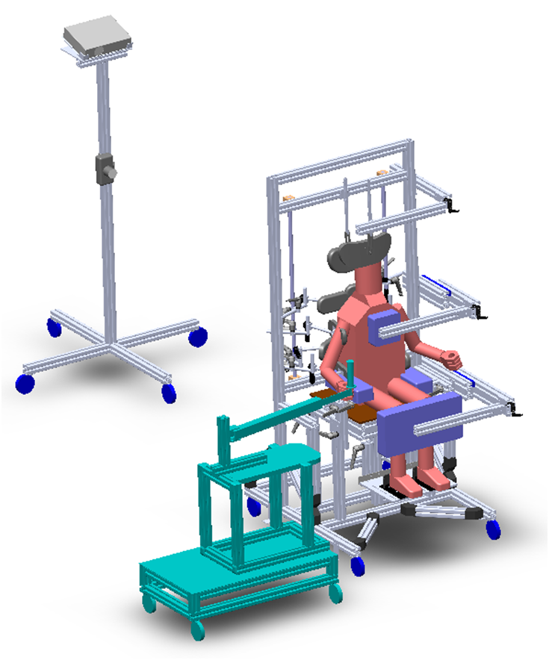

Second Clinical Investigation – Use of SMS with non-ambulant children with CP
A second clinical investigation was carried out to assess if the use of the SMS was feasible with non-ambulant children with CP. Initially four able-bodied children aged 5-12 years old were recruited to assess if the system conformed with the device specification and to provide baseline data of normal seating. These children were provided seating support to accommodate their posture; initially their pressure force distribution and spinal image were recorded while stationary. The children were then asked to use the joystick and computer game while the same measures were recorded.

Following the successful assessment of able-bodied children, six children with CP GMFCS IV-V aged 5-12 years old, with the cognitive and sensory ability to use the joystick, were recruited through the NHS. These children were assessed with varied amounts of postural support to assess differences to their seating parameters and function. The same procedure used with the able bodied children was repeated three times for each child. Initially support was provided to accommodate the child’s natural seated posture and any deformity (if present). The clinician then provided optimised seating setup based on their judgement alone, attempting to correct posture while maintaining minimal forces. Lastly each child was provided with the maximum amount of supportive forces to correct posture without causing discomfort.

Results
This study was a pilot study to assess the feasibility of measuring seating parameters for non-ambulant children with CP and the results have yet to be published. By providing adequate postural support it was feasible to measure spinal deformity, force/pressure distribution and upper limb function for non-ambulant children with CP while seated.

Results indicated that the differences between able-bodied and children with CP can be subtle. In the CP group, the results suggested that a reduction in flexion may cause weight distribution to move anteriorly. The sample size for this study was small, therefore all the clinical findings presented are speculative without a large-scale clinical study.

The device developed in this research provides a method of delivering objective and quantifiable measures for assessing seating prescriptions. It has the potential to improve clinical care for severely disabled individuals and consequently reducing the prevalence of life threatening scoliosis for non-ambulant children with CP.

Stakeholders associated with this project were involved throughout the process, and this facilitated a beneficial advance in the development of a pragmatic, user-friendly and useful solution in this field.

Future Development
Future development of the SMS will require a large scale clinical trial involving non-ambulant children with CP along with a number of able-bodied children. This study may be useful to identify parameters associated with poor seating posture and how disabled and able bodied seating posture and ability may differ. The SMS was not used to assess pelvic obliquity; to provide detailed analysis of the relationship between seated posture and pelvic obliquity it may be possible to integrate the SMS with routine pelvic X-rays in future trials.
References
Berryman F, Pynsent P, Fairbank J, and Disney S. 2008. A new system for measuring three-dimensional back shape in scoliosis. Eur. Spine Journal. 17:5, 663-672.

Cans C. 2000. Surveillance of Cerebral Palsy in Europe: a collaboration of Cerebral Palsy surveys and registers (SCPE). Developmental Medicine & Child Neurology. 42, 816-24.

Gericke T. 2006. Postural management for children with cerebral palsy: consensus statement. Developmental Medicine & child Neurology. 48:4, 244.

Levy A, Goldberg M, Mayo A, Hanley J and Poitras B. 1996. Reducing the lifetime risk of cancer from spinal radiographs among people with adolescent idiopathic scoliosis. Spine. 21:13, 1540–1548.

Sadani S, Jones C, Seal A, Bhakta B, Hall R, Levesley M. 2011. A pilot study of scoliosis assessment using radiation free surface topography in children with GMFCS IV and V cerebral palsy. Child: Care, Health & Development. In Press. Published online: 9 Aug 2011. DOI: 10.1111/j.1365-2214.2011.01292.x

Weightman A, Preston N, Holt R, Allsop M, Levesley M and Bhakta B. 2008. Engaging children in healthcare technology design: developing rehabilitation technology for children with cerebral palsy. Journal of Engineering Design. 21:5, 579-600.

