1. EMERGENCY PROCEDURES

SECURITY
- If you have any security concerns, please contact a venue employee or the organiser’s office. Inform them of the nature and location of the problem.
- Do not leave any personal belongings or valuables unattended on your stand, the venue and organisers cannot be held responsible for any losses.

FIRST AID

During builds and breakdowns, a designated first aider will be present throughout. Should you need medical assistance contact a venue employee or the organiser’s office. Inform them of the location and nature of the medical emergency. They will radio for assistance.

• If possible give the following information:
o Who you are o Who the injured person is o Exact Location o Nature of medical emergency o Is the patient male or female o Approximate age o Are they breathing, conscious or unconscious o Nature of illness – do they have chest pains/are they bleeding, etc.

DO NOT PHONE FOR AN AMBULANCE – a venue first aider will do this if required.

Alternatively, please visit the first aid room located in-between Charter Foyer and Central Foyer

All accidents, incidents or near misses must be reported to the Organiser/Venue Event Manager

FIRE

On discovering a fire:

- Raise the alarm by contracting a venue employee, informing them of the nature and location of the incident
- Remove persons in immediate danger to safety
- Close doors behind you
- Only tackle fire if exit is obstructed

EVACUATION

The building has a two-stage fire alarm system

The first stage alerts venue staff of a potential fire, which will instigate an investigation. At this point, you will not know anything about the ongoing investigation.

If a fire is identified during the investigation, or a secondary smoke detector is activated, the fire alarm will initiate the evacuation message. This message is a combination of a beacon and voice instruction The voice instruction relays the following message: -

“Attention Please! Attention Please! Will Everybody Please Leave The Building by The Nearest Exit. This Is An Emergency. The Staff Will Assist And Direct You. Please Do Not Use The Lifts”

- Immediately leave the building the nearest exit
- Do not use lifts
- Do not stop to collect personal belongings
- All persons are toe evacuate to the closest assembly point
- Do not leave the assembly point unless instructed
- Do not re-enter the building until instructed

The venue has two assembly points;
-The Rear Car Park, and The Front Forecourt, Windmill Street
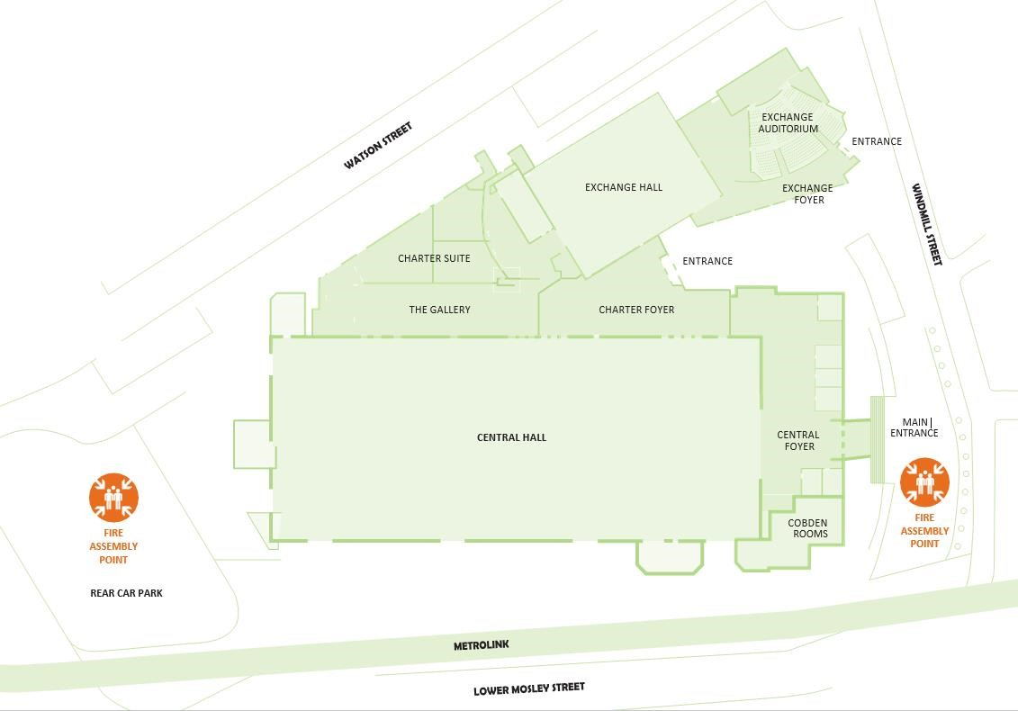

2. WELFARE ARRANGEMENTS

ORGANISERS OFFICE

The organiser’s office will be located in the Exchange Lower Foyer. If you need to contact a member of the organisers team on-site, please call +44 (0)7984515630.

TOILETS

Toilets will be provided during the build-up and breakdown periods in the following locations:

• There are two sets of male and female toilets available near the Exchange Auditorium as well as several disabled toilets

CATERING AND REFRESHMENTS

- Tea/coffee and water will be available in Central Hall
- Other catering outlets are available outside Manchester Central and in the surrounding areas

SMOKING
- Smoking (including e-cigarettes) is not permitted within the venue
- Smoking is only permitted in the designated smoking areas

ALCOHOL AND DRUGS
• Anyone found to be drinking alcohol or taking drugs will be asked to leave the venue

3. SITE RULES

Whilst working at PMG Conference 2018, it is important that you are aware of the safety rules, procedures and arrangements that are in place for your safety and that of your colleagues.

All of your employees and contractors are required to read these Site Rules prior to working at PMG Conference 2018 and the following apply to all staff, organisers, contractors and exhibitors:

- Comply with Venue Traffic Rules and follow the instruction of venue traffic marshals at all times
- Vehicle access into the halls has to be approved by the Venue/Organisers of the event.
- Any vehicle or plant driven within the hall must adhere to the 5MPH speed limit and operate with hazards/turned on lights.
- Drivers must give way to pedestrians within the event hall/s and pedestrians must give way to vehicles within the loading bay/s
- No persons are permitted to operate plant or machinery (including fork lift trucks) unless they have received adequate training
- Appropriate management and safe methods of working at height is required at all times – in any areas where working at height is being carried out, the immediate area must be controlled
- Ladder work must only be conducted for short work periods - you must NOT stand on the top tier of your ladders -any unsafe ladder work may result in the employee being ejected from the venue
- No substances are to be used in the hall which have not been pre-agreed by the venue and event organiser
- Any person suspected to be under the influence of drugs or alcohol will be ejected from the venue
- Appropriate PPE & footwear should be worn whilst working in the venue – flip-flops, open-toed sandals, etc. are NOT acceptable
- No hot works can take place in the venue without a Hot Works Permit being issued
- All contractor accidents, incidents & near misses must be reported immediately to the organiser
- Work Tidy - during builds and breakdowns, you must ensure aisles are kept clear at all times and that all waste is to be disposed of in an appropriate manner

