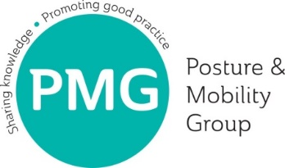
PMG Conference 2019:
‘Pitch your Product’ presentation application

This year PMG is offering a limited number of 5-minute presentation slots on the conference main stage for companies to ‘pitch a product’ to the whole conference. The session will run from 11.30am to 11.55am on Tuesday, 16th July 2019.

To apply for one of these 5-minute slots, please complete Sections 1 to 5 below, and return the form as instructed, to olwen.ellis@pmguk.co.uk by Wednesday, 24th April 2019.
Please note: applications will not be proofed before being sent to our Conference, Education and Communications Committee for judging. Any committee members with a conflict of interest (for example, any working for exhibiting companies) will not be allowed to judge.

The committee have provided the following bullets as a guide for Section 4:
- The presentation should preferably involve a novel product development – something partially or entirely new; or a novel application of an existing product
- It must include critical evaluation of the product relative to a clinical scenario (i.e. what worked well, what did not, what was learnt, action plan)
- Does the product provide cost effectiveness/efficiency in the short and/or long term?
- Does the product improve time effectiveness/efficiency?
- Is there research underpinning the device/application?
- Is there potential for generalisation to the posture and mobility population?

- Company name:

- Contact name and email address:

- Product name:

- Brief description of product and presentation (50 to 150 words)

- Product release date (if applicable):

Please email your completed form to olwen.ellis@pmguk.co.uk by Wednesday 24th April 2019.

