Record the contact details
for all delegates visiting your stand
Order a small, lightweight laser scanner using the Circdata Barcode Scanner Order Form and collect it from registration.

If you require additional scanners at the event, please come to registration to order them.
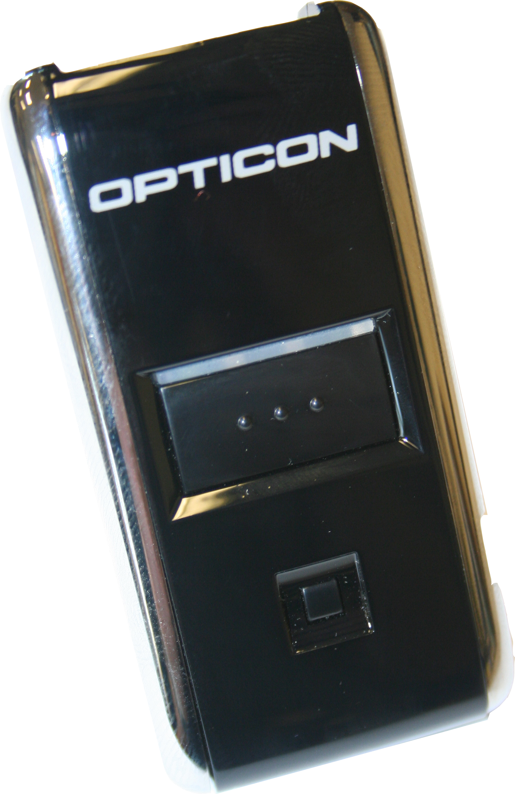

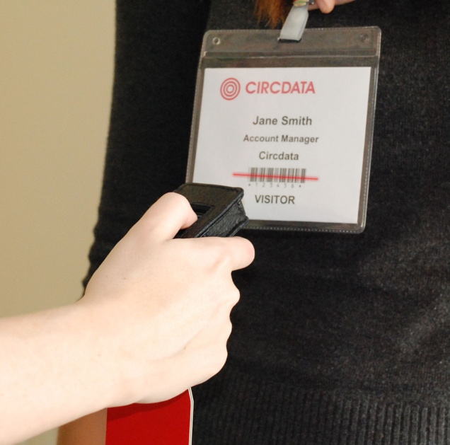
How they work

Every attendee is allocated a badge with a unique barcode before entry to the exhibition.

Simply scan each delegate that shows an interest in your products or services.

This scanned data will then be emailed to you after the event as an Excel file. It will contain details such as their name, job title, organisation and email address where available.

Please specify the number of scanners you require on the form, and they will all be available to collect from registration.

With multiple barcode scanners, you can spend more time speaking with your visitors and let the scanners do the hard work for you.

Barcode Scanner - Order Form
Please complete in BLOCK CAPITALS and return to the registration desk

Exhibition Name: PMG Conference
Exhibition Dates: 17th – 19th July 2017
Exhibitor Company Name:
Name of person to receive scanned data:
Email of person to receive scanned data:
Address for invoice:
City/Town: Zip code/Postcode:
State/County:
Country:
Tel No. Fax No.
E-mail address:
Stand No.
Ordered by (Please print name):
Job Title:

Select your method of payment
By cheque made payable to CIRCDATA
By Visa / MasterCard / Amex (Circle as appropriate)
Company VAT No.
Card Number
Start Date : Expiry Date:
Holders name: Issue No. Security No.
Signature:
Address:
City/Town: Zip code/Postcode:
State/County:
Country:

Please fill in your requirements | Price per unit | VAT at 20% | Total price | Units | Total to pay
Service and Set-up - includes file output to disc or by email post show. First Scanner | £100.00 | £20.00 | £120.00
Rental fee per additional Scanner | £100.00 | £20.00 | £120.00
General information and terms  Payment for additional scanners must accompany your order. Purchase orders are not accepted. Overseas exhibitors must pay in pounds sterling drawn on a UK bank or Credit Card. Scanners must be picked up and returned at the show. All scanners not returned within one hour of the show closing (last day) will be considered not returned. No refund on advance orders will be given. Please make sure that you return your scanners to the registration desk each day to ensure that your data is backed up. A charge of £300 will be made for any scanner not returned or returned damaged. CIRCDATA can only supply as much information as provided by the visitor on their registration card. We cannot guarantee that visitors will supply full data. CIRCDATA cannot be held responsible for data loss in the unlikely event of hardware failure, corruption or viral infection. |  |  |  | Grand total

