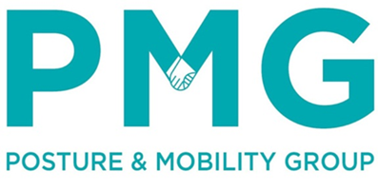
Posture & Mobility Group
29 Myrtle Close
Alphington
Exeter
EX2 8UX
T: 01392 477710
E: olwen.ellis@pmguk.co.uk
W: www.pmguk.co.uk

